ERP = Enterprise Resource Planning

Core ERP :

1. Operational portfolio {MRP (not CRM) – CIM}
2. Administrative portfolio {Accounting – Finance – HR – project managing -Tax payment}
3. Executive portfolio



Extended ERP :

1. CRM
2. PLM
3. CSM

ERP paradigms :

1. Information integration
2. Extension and modularity
3. Process prescriptiveness.

KPIs = Key Performance Indicators

ABC = Activity Based costing

CRM = Customer Relationship Management

1. Operational
2. Analytics
3. Executive

BPR = Business Process Reengineering -> With BPR, knowledge workers become generalists

PLM = Product Lifecycle Management

SCM = Supply Chain Management

OEE = Overall Equipment Effectiveness

1. The lower the efficiency/availability, the lower the OEE.
2. The higher the downtime, the lower the OEE.

Companies that can manage their business process by software like 1C:Drive:

1. Service companies
2. Distribution companies
3. Pro duction companies
4. Small manufacturing companies
5. A company doing import and export

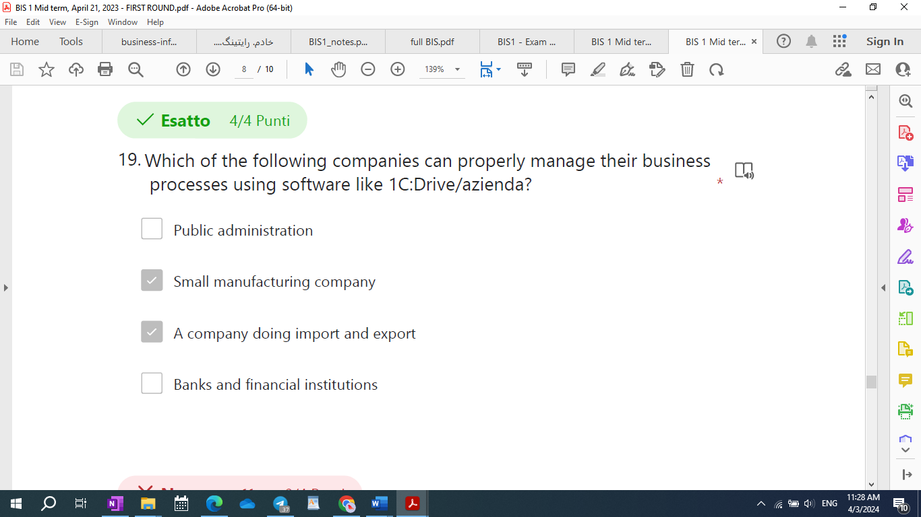

1. Bankes
2. Public administration
3. School
4. Social media companies
5. Financial in

SFA = Sale Force Automation

Typical objectives of SFA

1. Reduce the cost of customer acquisition.
2. Decrease customer churn.
3. Reduce bureaucracy for customers and increase responsiveness during the sales process.
4. Increase effectiveness of the sales force.

What are typical objectives of sales force automation (SFA)?

* 1. Reduce the costs of customer acquisition.
  2. Decrease customer churn.
  3. Reduce bureacracy for customers and increase responsiveness during the sales process.
  4. Increase the effectiveness of the sales force.

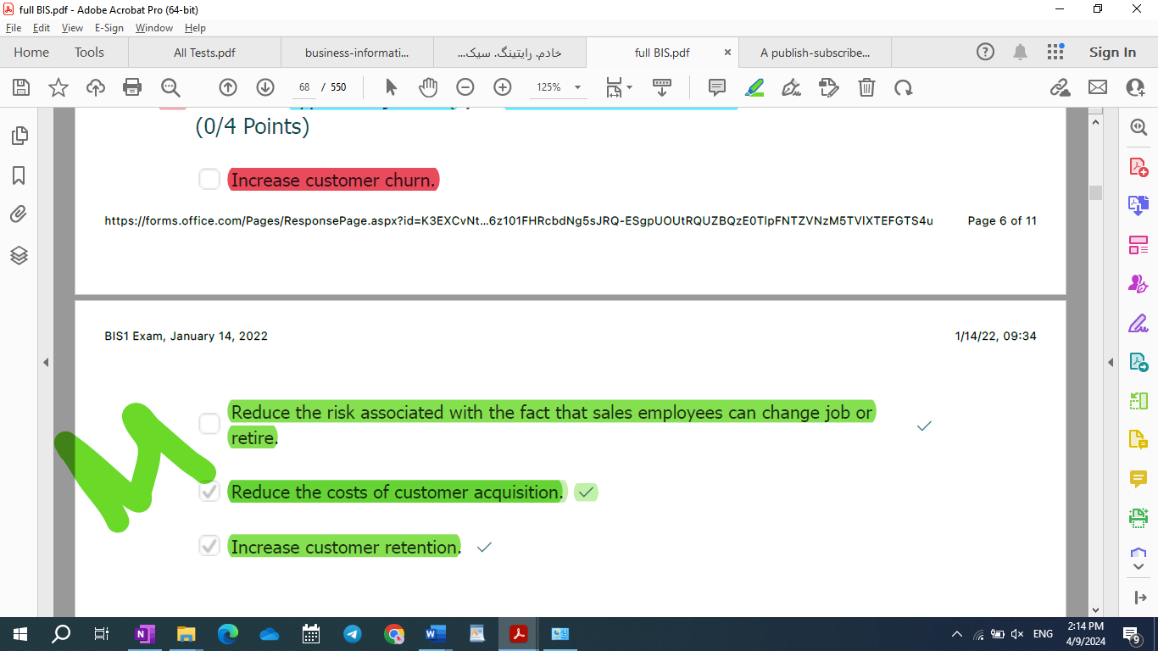

|  |  |
| --- | --- |
| Reduce | Increase |
| 1. Bureaucracy 2. cost of customer acquisition 3. customer churn 4. risk associated with changing job or retire | 1. responsiveness during the sale process 2. effectiveness of the sale force 3. customer retention |

Sell in / Sall out Data

sell in related to the sales from producer to distributor (Directly)

sell out related to the sales from producer to distributor to another distributor (Indirectly)

CIM = Computer integrated Manufacturing

MRP = Material Requirement Planning

CSF = Critical Success Factor

SAP = Systems, Application, and Products -> – Cloud based ERP interface

SAP HANA – in memory databases

1C:Drive/Azienda program

Main modules are: CRM – Sale – Product – Quality – Payroll – purchase – service – accounting -warehouse

DB = Databases

EDWH = Enterprise Data warehouse

15-R-M: Repeated Which of the following is a true statement about EDWH (Enterprise Datawarehouse)?

1. The structure of an EDWH is typically set on **one level**, the datamart.
2. The staging layer is where data are imported at first, in **both** staging and datamart layer the structure definition is driven by source structures
3. The structure of an EDWH is typically set to more levels, with a partial replication of the information between one level and the next.
4. The staging layer is where data are imported at first, in the datamart layer the structure definition is driven by analysis requirements.

|  |
| --- |
| The structure of a data warehouse is typically set to more levels, with a partial replication of the information between one level and the next. Which is typical one?   1. First level or Staging Area; Second Level or Data Mart 2. First level or Staging Area; Second Level or Reporting Layer 3. First level or Staging Area; Second Level or Data Mart; Third Level or Data Warehouse 4. First level or Staging Area; Second Level or Data Warehouse; Third Level or Data Mart |

ELT = Extract, transform, and Load

|  |  |  |  |  |  |  |  |  |  |  |  |  |
| --- | --- | --- | --- | --- | --- | --- | --- | --- | --- | --- | --- | --- |
| Technology = is a process and the sources needed to perform this process  Or  what a company capable of performing/doing  Technical system = a set of machines supporting a given technology  Information system = a subset of the technology of a company  Or  a set of information process that a given company can perform  IT architecture = a technical system supporting a given information system   |  |  |  | | --- | --- | --- | |  | Technology |  | | Technical system |  | Information system | |  | IT Architecture |  | |  | Technical innovations |  | |

|  |
| --- |
| List of Modules (SAP)  - SD Sales and Distribution (Ciclo Attivo)  - MM Materials Management  - PP Production Planning  - QM Quality Management  - PM Plant Managenent (manutenzione)  - HR Human Resource  - FI Finance  - CO Controlling  - AM Asset Management  - PS Project (gestione progetti)  - WF Workflow  - IS Information System (Sistema Statistico) |

* Important: 6-R-M: Which of these options represent a benefit of an OnCloud solution?

1. the old architecture can be simply switched off;
2. the IT skills required are the same as an on prem architecture;
3. lower cost with same performance as an on prem architecture;
4. more flexible scalability compare to an on prem architecture;

It seems that the option 4 is the only option, we can choose.

* Important: 9-R-M: Why is price the information system of markets?

1. Because market coordination is based on the execution of economic transactions, which in‐ volve a payment of a price.
2. Because through competition (in perfect market conditions), average market price is a reliable indication of the value that the client can obtain from the transaction.
3. Because price carries information on the quantity of products and is a driver of purchasing decisions.
4. Because price carries information on the quality of products and, in a perfect market system, is the driver of purchasing decisions.

14-R-M: What are correct statements on the dimension(s) of indicators in executive information systems?

1. Typical dimensions are time, customers and products.
2. Dimensions represent the units of measurement of KPIs.
3. Dimensions represent columns in the DWH tables
4. The value of an indicator is defined given a vector of values of relevant dimensions.

* 15- R-0: In a company with three BW environment (development and production), what is the purpose of the **development environment**?

1. Test the developments
2. There is always a unique environment, the production environment
3. Be able to make new developments with no impacts on the production environment
4. There is always a unique environment, the development environment

|  |  |
| --- | --- |
| purpose of the **development environment** | purpose of the **production environment** |
| **Make new developments** **no impact** **on production environment** | Final users **have access and can see data** with **no development ongoing** |

* 18-R-M: Please, tick statement(s) that correctly apply to **Activity Based Costing** (ABC) .

1. According to ABC, operations are associated with costs
2. According to ABC, operations can be associated with an internal pricing system
3. ABC enables the assessment of progress from an operational management perspective (time, production rate, use of production plants/machines)
4. With ABC, progress of operational activities can be reconciled with administrative cash flows

* 19-R-M: Why doesn’t non-IT technical innovation have an impact on scope economies?

1. Because scope economies are not related to innovation.
2. Because scope economies are inherently different from scale economies and do not originate from greater efficiency of production processes.
3. Because increasing scope economies requires better coordination and non-IT technologies do not support coordination.
4. Because non-IT technical innovation increases organizational **effectiveness** only.



|  |  |  |
| --- | --- | --- |
|  | CRM Modules |  |
| Operational | Analytical | Executive |
| 1. Sale force 2. Call center 3. Mobile 4. Agencies and shops 5. Mail | 1. Customer profiling 2. Discovering insight from customers data which are useful for business management. 3. Identification of new KPIs 4. Visualization tools | Selection and definition of customer KPIs  Definition of service and objective |

* 23-R-M: What are module(s) of operational CRM? *

1. Sales force
2. Mail
3. Call center
4. Agencies and shops

12

How can companies deal with environmental uncertainty according across decision theory?

1. They increase their information processing capacities (the capacities that go beyond the limits of

individual rationality) by implementing:

a. vertical information system.

b. horizontal information system.

2. Increase slack resources. Build up some reserve that it’s possible to use when it’s needed to insert flexibility. E.g. if you’re really fast with 3. processes and cycles, you don’t need to have a lot of resources in your warehouse, because you’re very quick at adapting at a changing according to the changes of the market demand.

So, it’s possible add slack resources by implementing:

a. a warehouse.

b. Create independent organizational units according to the divide et impera paradigm.

* 1-R-M: Please, tick consolidated belief(s) tieing technical innovation with organizational change for non-IT technologies.

1. Technical innovation increases the general complexity of managing a company.
2. Technical innovation increases organizational efficiency and effectiveness.
3. **There is no relationship between technical innovation and scope economies.**
4. Technical innovation increases the level individual specialization.

* 19-R-M: Why doesn’t non-IT technical innovation have an impact on scope economies?

1. Because scope economies are **not** related to innovation.
2. Because scope economies are inherently different from scale economies and do not originate from greater efficiency of production processes.
3. Because increasing scope economies requires better coordination and non-IT technologies do not support coordination.
4. Because non-IT technical innovation increases organizational **effectiveness** only.

Please, tick consolidated belief(s) tieing technical innovation with organizational change for non IT technologies. *

1. Technical innovation increases organizational efficiency and **effectiveness**.
2. Technical innovation enables scale economies.
3. Technical innovation increases individual specialization.
4. Technical innovation increases bureaucracy, but does not affect the formalization of work.

* 2-R-M: What are phase(s) of the CSF method?

1. Interview with knowledge workers
2. Robustness analysis: aimed at selecting KPIs
3. Refinement and documentation: presentation to customer, possible modifications, specification (written, but informal)
4. Predefinition: desk analysis

|  |
| --- |
| *CSF method - steps*  CSF method requires 4 phases:  • **Predefinition**: desk analysis  • **Interview**: aimed at identifying CSFs (made with top managers)  • **Robustness analysis**: defined for selecting the KPIs[1] *  • **Refinement and documentation**: go back to top managers and refine data |

* 3-R-M: Please, tick statement(s) that correctly apply to **analytical CRM**.

1. A typical activity of analytical CRM is customer profiling.
2. Analytical CRM is aimed at discovering insights from customer data that are useful for business management.
3. A typical activity of analytical CRM is reporting.
4. Analytical CRM provides inputs for the operational managements of campaigns.

what is **operational CRM**?

* [ ] Operational CM is the module of RM supporting the analysis of marketing data.
* [x] Operational RM refers to the modules of CM supporting different distribution channels.
* [ ] operational CRM is the module of CM managing the operational DB.
* [ ] Operational CRM does not exist.
* 5-R-M: How can companies deal with environmental uncertainty according to decision theory?

1. Increase slack resources.
2. Implement market coordination mechanisms.
3. Increase information processing capacity with horizontal information systems.
4. Increase information processing capacity with vertical information systems.

* 6-R-M: Please tick correct statement(s) on hierarchical control in market systems: page 21

1. In non perfect markets, customers may have some level of hierarchical control on their customers’ production processes.
2. Market and hierarchies are separate coordination systems that can mix only inside organizations.
3. In non perfect markets, customers can control their suppliers to some extent.
4. Hierarchical control does not exist in perfect market systems.

* 7-R-M: Which of the following elements are managed on a standard ERP Software like 1C:Drive/Azienda?

1. Information like prices and costs
2. Documents related to business processes
3. Catalogues with the main data of the company
4. User profiles

* 8-R-M: What is the role of concurrent engineering and inside-out production in MRP?

1. They are necessary to make sure that the production processes of different products are as similar as possible.
2. They are necessary to support the redesign of organizational processes to enable greater production efficiency.
3. They are necessary to ensure that different products “look” different, while sharing many internal components.
4. They are necessary to make sure that the number of common components across different products is maximized.

* 12-14-R-M: What is the meaning of information integration according to the ERP paradigm?

1. All information should be stored in the same database.
2. All ERP functionalities should access the same information.
3. Information should have the same quality across all organizational processes.
4. Information can be stored in multiple databases but should have a common integrated conceptual and logical schema.

* 13-R-M: What is the role played by PCs in BPR (business process reengineering)?

1. PCs can be integrated with CIM and MRP.
2. PCs represent a production technology
3. PCs provide enough flexibility to support knowledge work and related decision-making activities.
4. PCs automate knowledge work

* 14-QAI-M: Which data visualization systems can be used only by users with advanced skills?

1. Self service
2. Ad Hoc Dashboards
3. Pixel perfect reporting
4. Data exploration

* 15- R-0: In a company with three BW environment (development, quality, and production), what is the purpose of the **development environment**?

1. Test the developments
2. There is always a unique environment, the production environment
3. Be able to make new developments with no impacts on the production environment
4. There is always a unique environment, the development environment

* 16-R: In a company with three BW environment (development, quality and production), what is the purpose of the **production environment**?
  1. The production environment is where final users have access and can see data with **no developments** ongoing.
* 16-R-M: Please, tick correct examples of inter-functional information processes in manufacturing: 52

1. Production management
2. Knowledge management
3. Order management
4. Material management

* 17-R-M: Which of the following functionalities are available on a standard ERP Software like 1C:Drive/Azienda?

1. Communication with instant messaging app like telegram
2. Management of work in progress
3. Posting to social media
4. Multi-language interface

* 18-R-M: Please, tick statement(s) that correctly apply to Activity Based Costing (ABC) .

1. According to ABC, operations are associated with costs
2. According to ABC, operations can be associated with an internal pricing system
3. ABC enables the assessment of progress from an ~~operational management perspective~~ (time, production rate, use of production plants/machines)
4. With ABC, progress of operational activities can be reconciled with administrative cash flows – (can be not cant be)



* 19-R-M: Why doesn’t non-IT technical innovation have an impact on scope economies?

1. Because scope economies are not related to innovation.
2. Because scope economies are inherently different from scale economies and do not originate from greater efficiency of production processes.
3. Because increasing scope economies requires better coordination and non-IT technologies do not support coordination.
4. Because non-IT technical innovation increases organizational effectiveness only.

The first thing that I want you to understand is a first important distinction: **manufacturing VS service companies**.

1. *In manufacturing companies*, company produces tangible/physical products.
2. *In services companies*,company produces intangible products, a service. You can’t touch it and typically services are made ofinformation. For example, education is a service.

what you can do with\functionalities available on a standard ERP software:

**Correct answers:**

1- manage the main process of a company

2- manage bills of materials and works in progress

3- manage multiple sale orders and calculate costs

4- manage order from client and calculate profit

5- manage supply of goods

6- comparing offers from different suppliers

**Wrong answers:**

**1- manage the company blog**

**2- Design a company website**

**3- to manage directly a web-commerce site**

*Information Processing Perspective of Organizational Theory*

**1. Decision theory**

* 24-R-M: According to decision theory, why are information exchanges between functions (or units) inevitable?

1. Because functions need to cooperate on the same cross-functional production processes and this cooperation requires information exchanges.
2. Because bounded rationality forces individuals and hence functions and units to cooperate in information processing tasks **to reach a common goal.**
3. Because the main criterion for division of labor are functional specialization as opposed to information independence.
4. Because of the nature of information, which is very easy to share and is not destroyed by use.

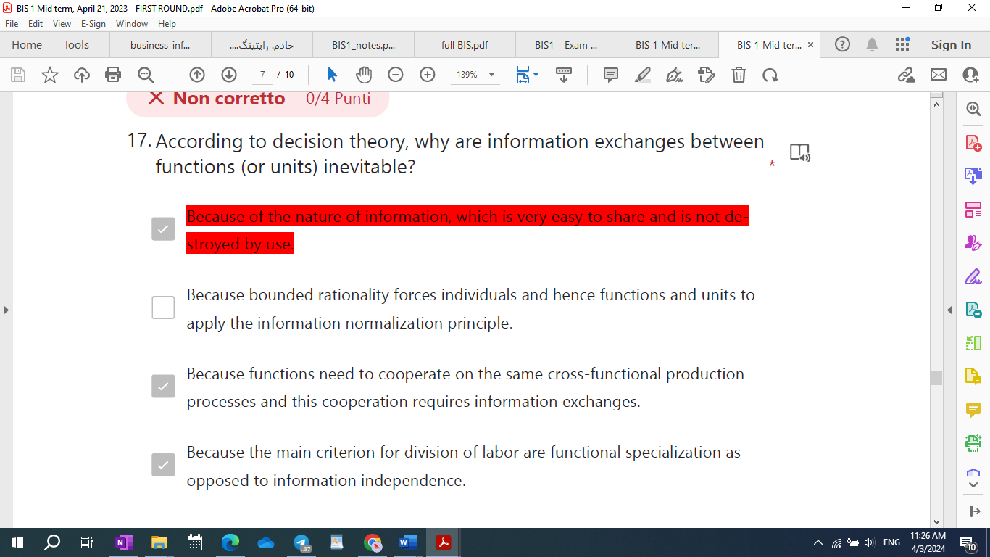

* 5-R-M: How can companies deal with environmental uncertainty according to decision theory?

1. Increase slack resources.
2. Implement market coordination mechanisms.
3. Increase information processing capacity with horizontal information systems.
4. Increase information processing capacity with vertical information systems.

* What are the activities constituting the logistic cycle in manufacturing companies?

1. Procurement, physical transformation of materials, order management.
2. Procurement, production, sales and distribution.
3. Acquisition and physical management of materials, physical transformation of materials, order management, external logistics, post sale processes.
4. Procurement, production, logistics.

* How does transaction economics overcome the limits of decision theory?

1. By considering market coordination in addition to hierarchical coordination.
2. By considering behavioral uncertainty in addition to environmental uncertainty.
3. By considering organizations as open systems.
4. By recognizing the limitations of hierarchical systems.

* How does transaction economics overcome the limits of decision theory?
* By considering behavioral uncertainty in addition to environmental uncertainty.
* By considering organizations as open systems.
* By recognizing the limitations of hierarchical systems.
* By considering market coordination in addition to hierarchical coordination.

**2. Transaction cost economics**

**3. Agency theory**

**q - how does agency theory overcome the limits of transaction economics: by recognizing that**

**1- there exists a continuum between market and hierarchy**

**2- there exists market recognition mechanisms inside organizations**

**The Impact of technical innovation on non IT organizations:**

**1. Technical innovation increases organizational efficiency, technical innovation allows company to**

**produce more with less (time, resources, people); [but not more effective]**

**2. Technical innovation enables scale economies, the word scale should suggest that we are talking**

**about economies, reduction of costs, that we obtain through the scale of the production system of**

**the organization. The larger is the organization, the greater is the scale economies. Consider the**

**acquisition of a new technology, so a company makes a buy decision, it has to make an investment,**

**that has to be amortized[2] across a larger production for the company to be able to cut on unit**

**production costs.**

**3. Technical innovation causes an increase in the optimal minimum organizational size, this is a**

**direct consequence of scale economies. That is a must for a company, because it has to grow.**

**4. Technical innovation increases individual specialization**

**5. Tayloristic assumption: there exists an organizational optimum, optimal process obtained**

**through optimal synchronization of individual tasks. Given a production goal, there is just one**

**optimal way to organize production: the one that minimize the time required from the beginning to**

**the end of the production chain.**

**6. Groupwork was not an issue (not studied)**

**7. Technical innovation increases bureaucracy and formalization of work**

**8. Overall, technical innovation increases the complexity of managerial tasks**

* 2-R-M: What are phase(s) of the CSF method?

1. **Interview with knowledge workers**
2. Robustness analysis: aimed at selecting KPIs
3. Refinement and documentation: presentation to customer, possible modifications, specification (written, but informal)
4. Predefinition: desk analysis

|  |
| --- |
| *CSF method - steps*  CSF method requires 4 phases:  • **Predefinition**: desk analysis  • **Interview**: aimed at identifying CSFs (made with top managers)  • **Robustness analysis**: defined for selecting the KPIs[3] *  • **Refinement and documentation**: go back to top managers and refine data |

Several ***determinants***of **uncertainty**

1. *Market dynamism*
2. *Number of suppliers in the market*
3. *Variety and variability of the market requirements*

**Elements are managed on standard ERP software:**

**1- user profile**

**2- Information like price and costs**

**3- documents related to business process**

**4- catalogs with the main data of the company**

**Documents are managed on standard ERP software:**

**1- Production orders**

**2- purchase orders**

**Processes are managed on standard ERP software:**

**1- Management of sales processes**

**2- Management of production**

**3- Management of purchases**

1. Management of sales processes
2. Management of production
3. Management of website
4. Management of purchases

6) Which of the following processes are managed by IC Drive

1. Warehouse

2. Production

3. Sales

4. Quality

**Three inter-function information processes** (*Order, Material, Operation*) from our computer science

Perspective

Materials requirements planning (MRP)

MRP as we said, is a first step towards the vertical integration between the operational portfolio and the

executive portfolio. By conventional, MRP is considered part of the operational portfolio and it’s called

vertical integration of the operational portfolio.

***Scope economies*** are economies that come from a better planning of how resources are used

**Concurrent engineering and inside-out production** processes enable company to produce products that

are different from the outside but are actually the same in the inside. So, the core components and also the how finished goods and also the production part of the production process is the same and shared.

If you have that, one can actually do is make your plans more flexible.

* 8-R-M: What is the role of concurrent engineering and inside-out production in MRP?

1. They are necessary to make sure that the production processes of different products are as similar as possible.
2. They are necessary to support the redesign of organizational processes to enable greater production efficiency.
3. **They are necessary to ensure that different products “look” different, while sharing many internal components.**
4. They are necessary to make sure that the number of common components across different products is maximized.

While CIM is achieve to greater efficiency, MRP is meant to achieve greater effectiveness. The way

company achieve that, with MRP is by taking advantage of scope economies. Those are economies that

come from a better planning, a better utilization of all the resources that exist in the organization, and that greater utilization is achieved by a more effective planning.

Functionalities of CIM

1. **Transformation processes**
2. **Workforce management**
3. **Plant management**
4. **Materials management**
5. **Quality management**

Before network connection, a pc was separate from other machine, only Office was used. There were also mainly two types of info: gaming and Office (made the secretary’s job more complex even if automated something). In this case, with Office, the impact of IT has been observed to lead to lower specialization. The first time that this has been observed was with secretarial work.

We now have a PC that is a tool, that is **used by office workers, knowledge workers, workers who work with information**. A PC is the first computing technology that has been applied to knowledge work, and it’s been observed that it has a very peculiar and innovative impact on organizational change.

What *knowledge workers* do in services is production and distribution (mainly production); production role is the same type of role that manual workers have in manufacturing. In a way PC are used by people that have the same role, in services, as people that have been replaced by robots in manufacturing. Of course, PC don’t replace white collars as robots did with blue collars, they just changed their jobs making it necessary to be more qualified to do an office job.

* 13-QAI-M: What is the role played by PCs in BPR (business process reengineering)?

1. PCs can be integrated with CIM and MRP.
2. PCs represent a production technology
3. PCs provide enough flexibility to support knowledge work and related decision-making activities.
4. PCs automate knowledge work

Horizontal and vertical integrated in services has occurred all at once:

• **Horizontal integration**: integration of portfolio along operational processes. *The enabling technology is Personal Computers.*

• **Vertical integration**: as a subsequence of horizontal integration; availability of operational information to the executive functionality of the portfolio of a company*. The enabling technology is Client-Server architectures.* (Horizontal -> processes; Vertical -> decision making) both steps have occurred almostsimultaneously along the timeline.

* 11-R-M: What are the steps of information transformation through ETL? *

1. Data quality control and cleaning
2. Source selection
3. Data transfer
4. Data aggregation

Information transformation (ETL)

1. Selection of data source

2. Data quality control and data cleaning

3. Data integration

4. Data aggregation

* 15-R-M: What primarily distinguishes ERP software from stand-alone targeted software is:

1. ERP has a common central database from which the various ERP software modules access information.
2. ERP is a modular software system.
3. ERP has one only common module.
4. ERP always has multiple databases, one for each module.

This question may have multiple correct options.[4]

* 17-QAI-M: Which of the following modules/sections are available on a standard ERP Software like 1C:Drive/Azienda?

1. Sales
2. Production
3. Social media management
4. Performance

Modules or sections in standard ERP

1. Sales
2. Production

* 21-R-M: Repeated What are classes of information stored in the operational database?

1. Catalog information
2. Operations planning information
3. General ledger information
4. Transaction information

|  |
| --- |
| Classes of information in the operational database  *Classes of operational information*  • ***Transaction information*:** describes the flow of operational activities.  Example: contract, start and end time of production activity  • ***Operations planning information*:** describes the objectives and the expected results of operational activities. We know that we have the operations, inter-functional information flow. We said operations are identified; each individual task is identified.  • ***Catalog information:*** represents basic knowledge and is totally independent of the flow of activity,  is relatively static. It’ doesn't flow with the inter-functional processes but it is not totally static because it changes overtime, but with respect to the activities of the processes that are performed in the organization, we can consider it rather static.  Example: product structure, phone directory |

* 24-R-M: What is SAP BW?

1. SAP BW is a tool to create dashboards
2. SAP BW is a SAP ERP
3. SAP BW is a tool used to create planning functions
4. SAP BW is a tool for datawharehouse creation of SAP

Inter-functional information in service companies(kos)

1. knowledge management
2. order management

Inter-functional information in manufacturing(mom)

1. material management
2. order management

**core functionality of ERP**:

Accounting

CIM(in manufacturing)

Human Resources = Personnel

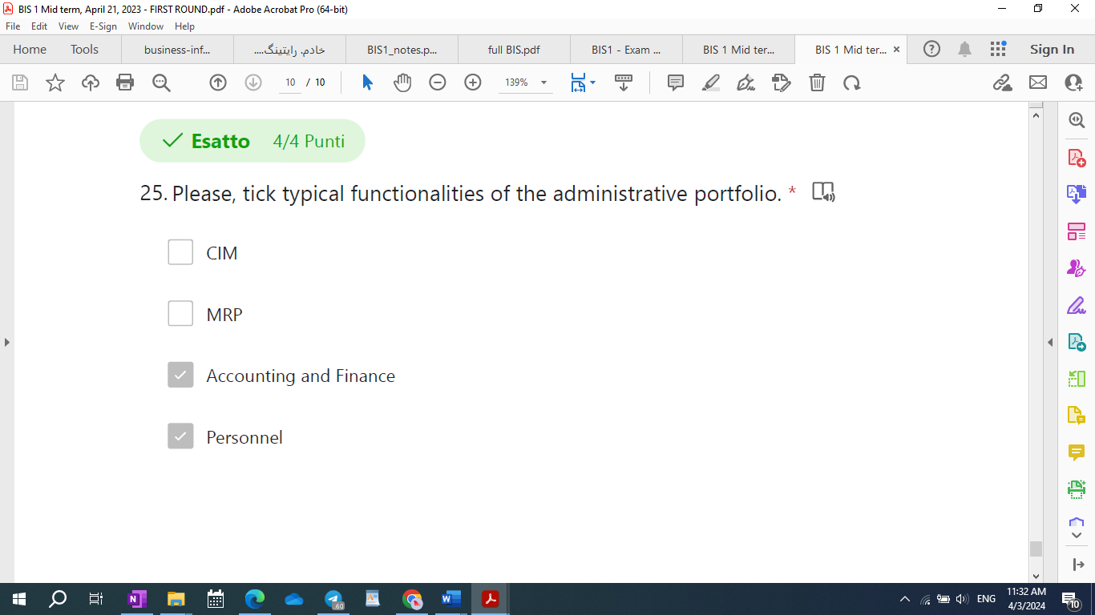

CRM is for extended ERP:

* 22-R-0: Repeated ERPs represent the last step of an integration process, since:

1. ERPs do not enable a real-time reconciliation of budgets, resource consumption, progress of operations and cashflows.
2. ERPs complete integration of operational and executive portfolios
3. ERPs complete integration of operational and administrative portfolios
4. ERPs complete integration of operational and executive with the administrative portfolio

* 23-R-M: What are correct statement(s) on CSF?

1. A CSF should be measured with one (the most significant) KPI
2. A CSF is a necessary condition for organizational success.
3. A CSF should be measured with multiple KPIs
4. CSF stands for critical success factor

|  |
| --- |
| 1. The lower the efficiency/availability, the lower the OEE. 2. The higher the downtime, the lower the OEE. |

What are typical KPIs of salesforce automation?

1. Churn( lost client/total number of clients)
2. Productivity (total sales / number of sales employees)
3. Effectiveness of the contacts (number of contacts / number of contracts)

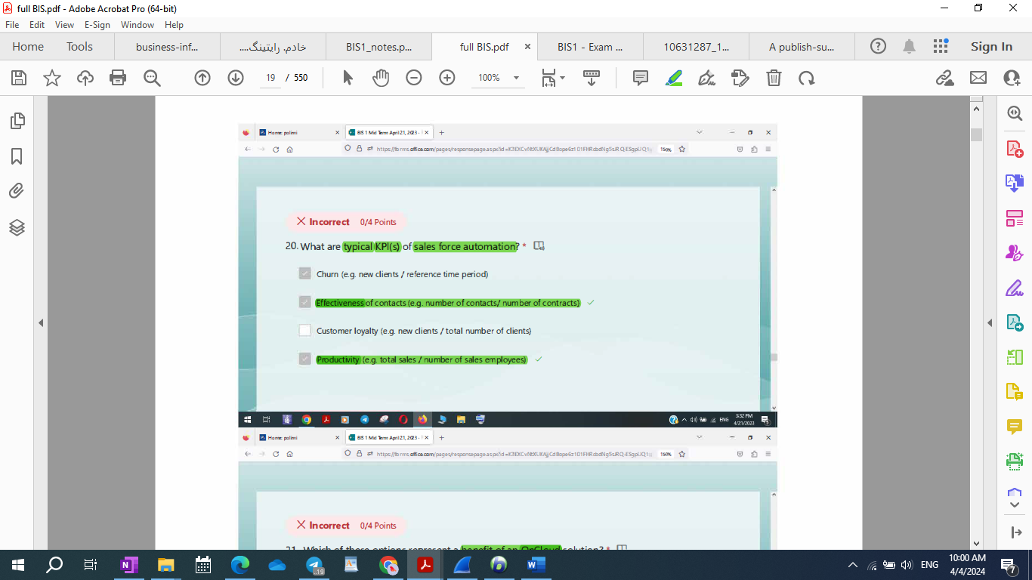

* 20-R-M: What are typical KPI(s) of sales force automation? *

1. Customer retention (e.g. new clients / total number of clients)
2. Productivity (e.g. total sales / number of sales employees)
3. Effectiveness of contacts (e.g. number of contacts/ number of contracts)
4. Churn (e.g. lost clients / total number of clients)

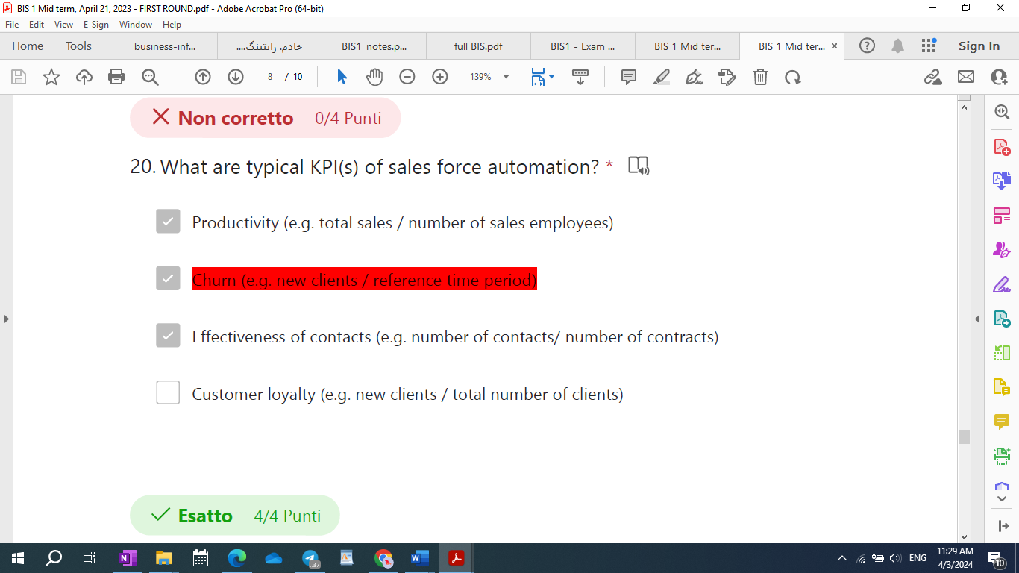

Can hierarchical control occur inside market system?

* [ ] No.
* [x] Yes, when customers can control their suppliers to some extent.
* [x] In perfect market systems, no.
* [ ] In perfect market systems, yes.

What is bounded rationality? *

* 1. Indicates limited information processing capacity of individuals.
  2. The reason why individuals cooperate.

R-0: Which costs are **lower in a hierarchy** compared to a **market coordination mechanism**?  
(4/4 Points)  
1- Coordination costs.  
2- Knowledge management costs.  
3- Transaction costs.  
4- Production costs.

**What are the correct inputs and outputs of the post settlement phase of an economic transaction?**

Input: exceptions, Output: exception management procedures.

|  |  |  |
| --- | --- | --- |
| Post settlement phase and economic transaction | Input: exceptions | Output: exception management procedure |
| Negotiation phase and economic transactions | Input: set of suppliers | Output: one supplier and new requirement (both specified a contract (SLAs)) |
| Execution phase and economic transaction | Input: Contract | Output: Product/Service and expectations with respect to SLAs |
| Match-making phase and economic transaction | Input: requirement | Output: set of candidate suppliers that satisfy initial requirements |



**Important1:** What are the characteristics of market systems?

they reduce **behavioral uncertainty** by **leveraging opportunism**.

market **coordination** involves the **execution of transaction**.

Markets replace **hierarchies**, since markets have lower production costs.

In market systems **production** costs are lower, as individuals tend to be very efficient.

**Important2:** What are the characteristics of market systems?

they reduce behavioral uncertainty by **leveraging opportunism**.

market **coordination** involves the **execution of transaction**.

Markets replace **hierarchies**, since markets have lower production costs.

In market systems **coordination** costs are lower, as individuals tend to be very efficient.

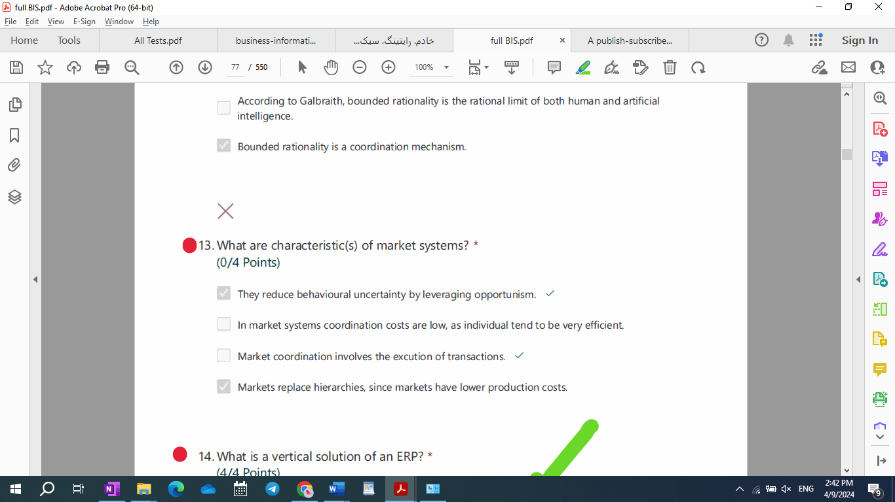

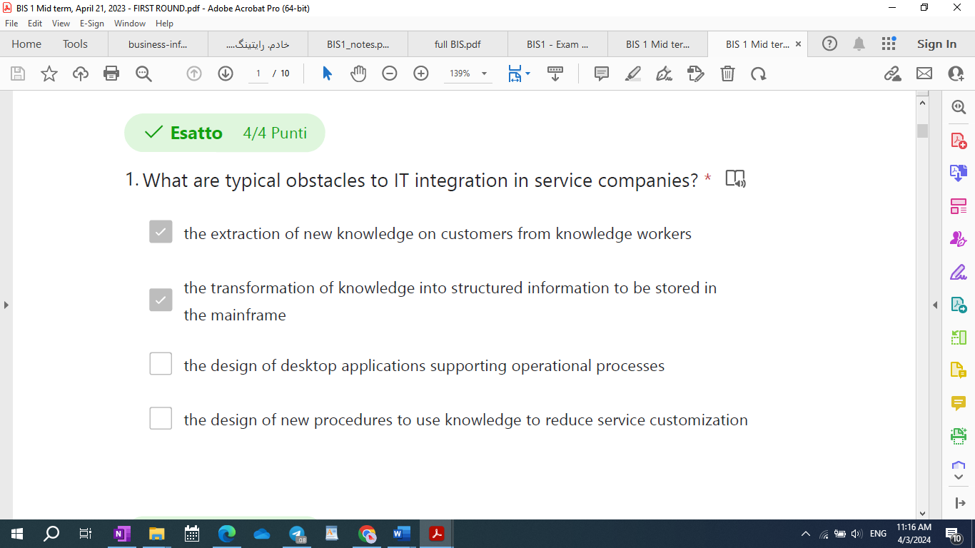

Manufacturing activity cycle (Mac DonaLd)

1. Logistic cycle
2. Development cycle



Public administration, small manufacturing company, a company doing import and export, banking and financial institutions.

* 9-R-0: Which of the following documents released during a BI project includes the Business user requirements?

1. Business Blueprint
2. User acceptance test document
3. Technical Design Document
4. Integration test documents

Which of the following are documents released during a BI project with waterfall approach?

1. Business Blueprint, a document for functional requirement collections
2. Technical Design document, a document focused on the business requirements
3. Technical Design document, a document focused on the technical solution
4. Business Blueprint, a document for resource planning

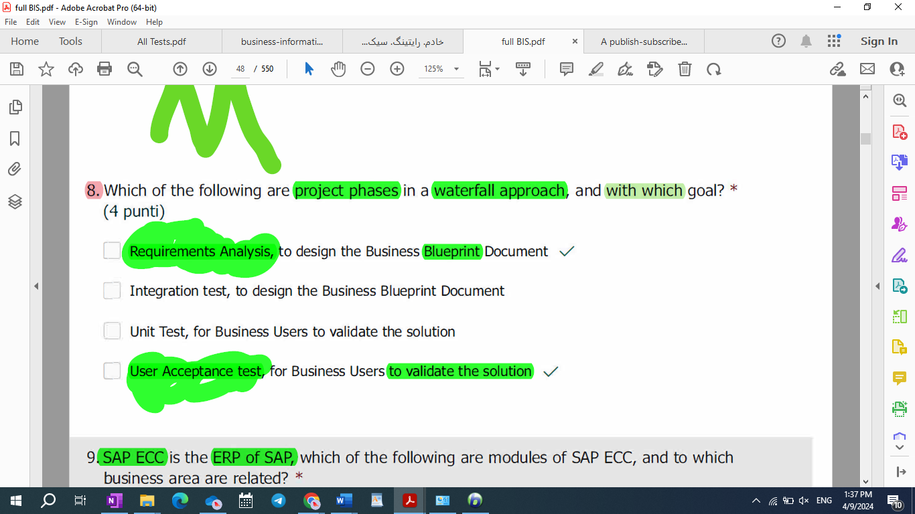

R-0: Repeated Which of the following Test procedure is performed with Business users?

1. Software installation test
2. User Acceptance Test
3. Integration Test
4. Unit Test

Why is the meaning of having a “balanced” set of KPIs to calculate the incentives of call-center operators? *

1. It means measuring a balanced set of indicators such as average call time, first call resolution, customer satisfaction.
2. It means sizing the call center to minimize customers’ waiting time.
3. It means measuring both efficiency and effectiveness.
4. It means measuring the efficiency of a team as opposed to an individual operator.

* Why is the meaning of having a "balanced" set of KPIs to calculate the incentives of call-center operators? (x3)

1. It means measuring a balanced set of indicators such as average call time, first call resolution, customer satisfaction.
2. It means measuring both efficiency and effectiveness.

* 24-R-M: According to decision theory, why are information exchanges between functions (or units) inevitable?

1. Because functions need to cooperate on the same cross-functional production processes and this cooperation requires information exchanges.
2. Because bounded rationality forces individuals and hence functions and units to cooperate in information processing tasks to **reach a common goal**.
3. Because the main criterion for division of labor are functional specialization as opposed to information independence.
4. Because of the nature of information, which is very easy to share and is not destroyed by use.

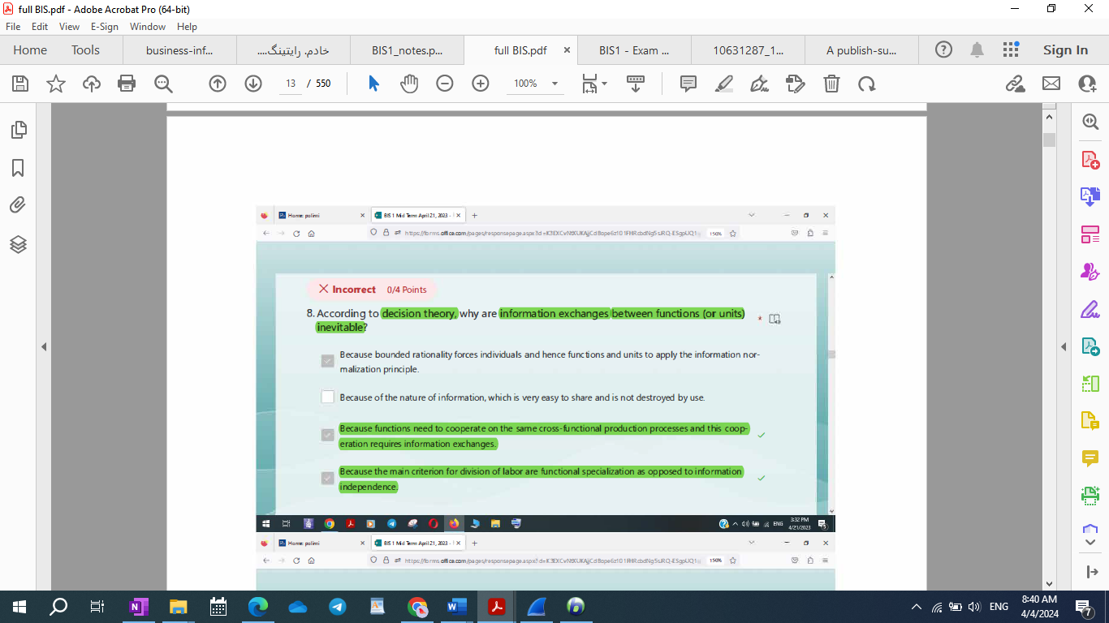

IT integration in service companies

What are obstacle(s) to IT integration in service companies?

* [x] The learning process involved by knowledge management.
* [ ] The breadth of the service industry in terms of sub-industries.
* [ ] The lack of automation technologies.
* [ ] The skill shortage.

**Which of the following functionalities are available on standard ERP Software 1C:Drive/azienda (tick all the correct ones)?**

[x] Multi-languages

To manage purchases

To manage accountancy

[x] Demand planning

[x]management of production order

[x] To get useful reports regarding your business

[x] Communication with instant messaging app like telegram

[x] Communication with telegram and others instant messaging

[x] Import/Export of documents in various format

[x] Generation and copy of documents

[x] Personalization of user interface

**What you can do with ERP Software 1C:Drive/Azienda (tick the correct ones)?**

[x] Manage Bills of Materials and Production Order

[ ] Manage the company blog

[x] Calculating the profit of a client order

[x] Manage orders from client calculating the profit

[x] Comparing Supplier offers

[ ] To manage directly a web-commerce site

[x] Manage supply of goods

[x] Manage supply of goods comparing offer from various supplier

[x] Manage orders from Client

* 19-R-M: Why **doesn’t** non-IT technical innovation have an impact on scope economies?

1. Because scope economies are not related to innovation.
2. Because scope economies are inherently different from scale economies and do not originate from greater efficiency of production processes.
3. Because increasing scope economies requires better coordination and non-IT technologies do not support coordination.
4. Because non-IT technical innovation increases organizational effectiveness only.

******************************\

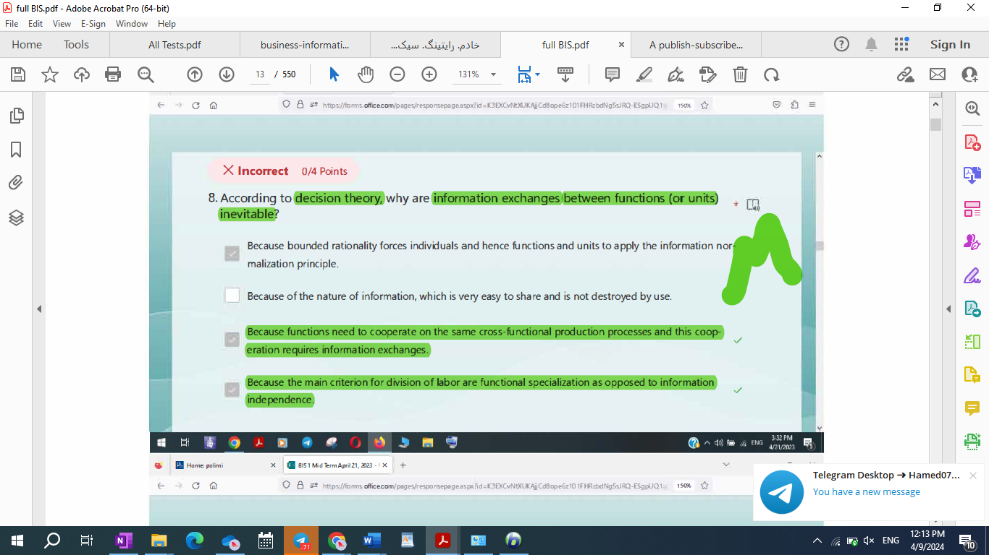

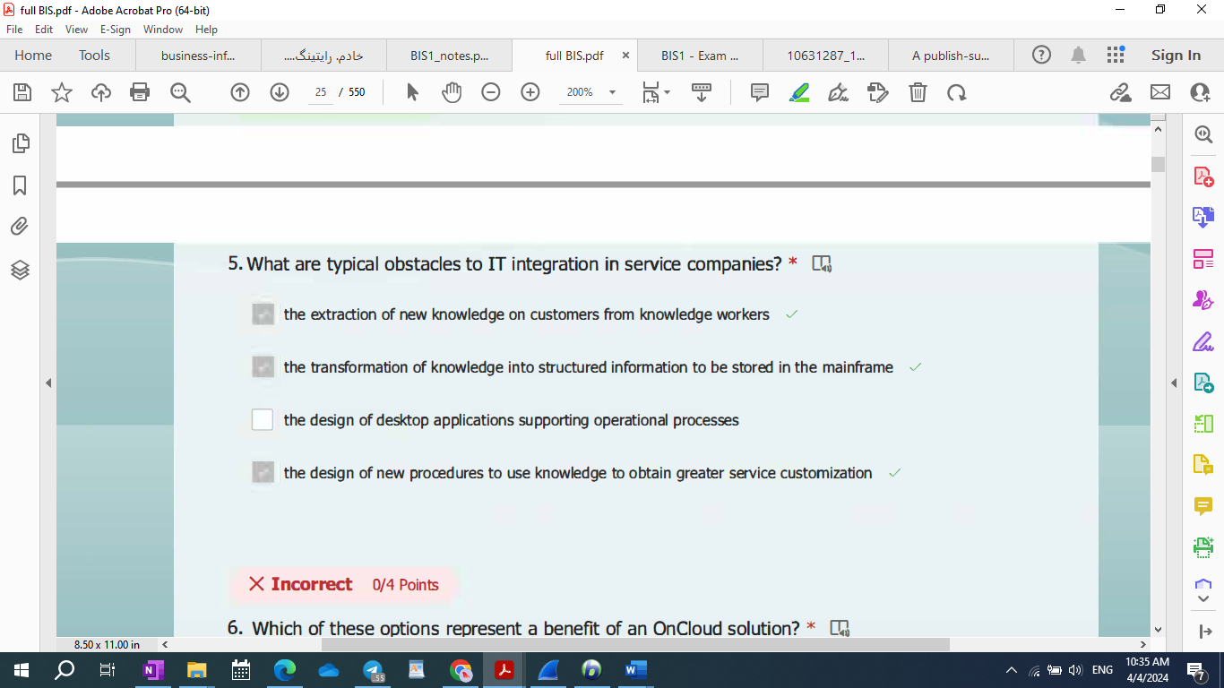

* 22-R-M: What are typical obstacles to IT integration in service companies? *

1. the extraction of new knowledge on customers from knowledge workers
2. the transformation of knowledge into structured information to be stored in the main frame.
3. the design of desktop applications supporting operational processes
4. the design of new procedures to use knowledge to **reduce** service customization

* 21-R-M: What are typical obstacles to IT integration in service companies? *

1. the extraction of new knowledge on customers from knowledge workers
2. the transformation of knowledge into structured information to be stored in the main frame.
3. the design of desktop applications supporting operational processes
4. the design of new procedures to use knowledge to **obtain greater** service customization.

Why is knowledge management complex? *

1. Because it involves the use of PCs and hence a significantly broader software variety.
2. Because it requires the design of new procedures to use knowledge to obtain greater service customization.
3. Because unstructured knowledge must be transformed into structured information be stored in the mainframe.
4. Because it involves the extraction of new knowledge on customers from knowledge -workers.

******************************************************/

Please, tick consolidated belief(s) tieing technical innovation with organizational change for non-IT technologies.

* [ ] Technical innovation increases organizational efficiency and **effectiveness**.
* [x] Technical innovation enables scale economies
* [x] There exists an **organlizational optimum**, optimal process obtained through optimal synchronization of individual tasks.
* [x] **Technical innovation does not enable scope economies.**
* [x] Technical innovation increases individual specialization.
* [ ] Technical innovation simplifies management.
* [ ] Technical innovation enables scope economies.

[ ] Technical innovation increases bureaucracy, but does not affect the formalization of work.

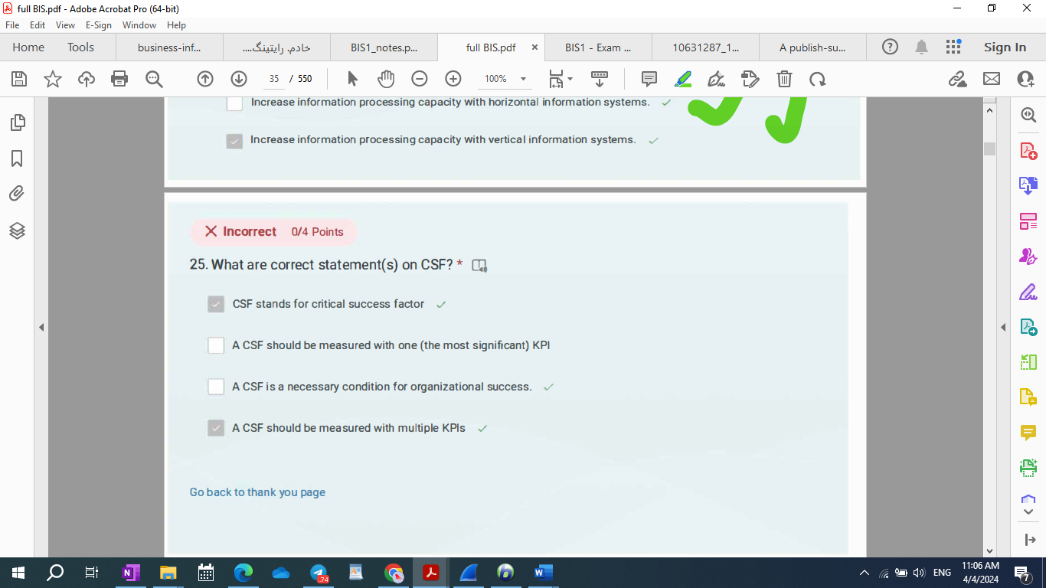

* 23-R-M: What are correct statement(s) on CSF?

1. A CSF should be measured with one (the most significant) KPI
2. A CSF is a necessary condition for organizational success.
3. A CSF should be measured with multiple KPIs
4. CSF stands for critical success factor

* Repeated What are phase(s) of the CSF method?

1. Refinement and documentation: presentation to customer, possibile modifications, specification (written, but informal)
2. Robustness analysis: aimed at selecting KPIs
3. Interview with knowledge workers
4. Predefinition: desk analysis

What are the steps of the CSF method?

1. Interview, analysis, documentation, implementation

2. Preparation, documentation, interview, reporting

**3. Preparation, interview, robustness analysis, refinement**

4. Preparation, interview, reporting, implementation

Please, tick the correct definition of IT intensity.

1. IT intensity is the actual ability of IT to satisfy the information processing requirements of organizational processes.
2. IT intensity is the degree to which a company’s management considers IT as a strategic lever:
3. IT intensity represents the size and complexity of the information used by the processes of an organization.
4. IT intensity is the organizational consequence of environmental uncertainty, as companies can handle uncertainty with IT.
5. IT intensity is the organizational consequence of environmental uncertainty, as companies can handle uncertainty with IT.

How does agency theory overcome the limits of transaction economics? * (0/4 Points)

* 1. By studying employment contracts as a special-purpose transaction.
  2. By recognizing that there exists a continuum between markets and hierarchies.
  3. By recognizing that hierarchies can fail and can be replaced by market systems.
  4. By recognizing that there exist market coordination mechanisms inside organizations.

What are drivers of IT intensity according to Porter?

1. Degree to which information processing activities are structured and, thus, can be easily translated into a computing procedure (predetermined steps and decision tree).
2. Volumes, i.e. the amount of information to be processed.
3. Frequency with which a given operation is repeated.
4. Computational complexity of operations, the simpler, the better.

6) Which of the following processes are managed by IC Drive

1. Warehouse

2. Production

3. Sales

4. Quality

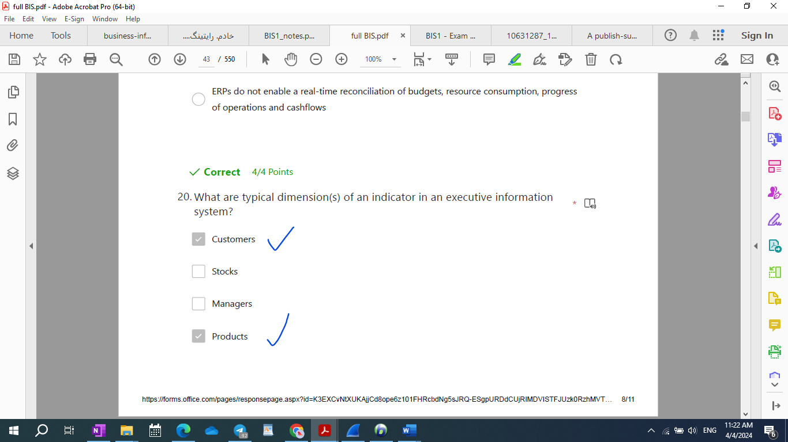

* The knowledge management process requires: *
  1. the extraction of new knowledge on customers from knowledge workers,
  2. the transformation of this knowledge into structured information to be stored in the mainframe,
  3. the design of new procedures to use this knowledge to obtain greater production efficiency
  4. A learnig process

**Why are PCs enabling technologies of Business Process Reengineering (that is horizontal and vertical**

**integration of the operational portfolio in service companies)?**

1. PCs are enabling technologies of BPR since they help horizontal coordination.

**2. PCs are enabling technologies of BPR since they help individual workers overcome the**

**boundaries of their individual rationality and become generalists.**

**3. PCs are enabling technologies of BPR since they support the knowledge management process.**

**4. PCs are enabling technologies of BPR since they represent the key technology to collect operating**

**information in electronic format at the time when it is first created (similar to robots in**

**manufacturing).**

* 10-Among the following, select (tick) the correct statement(s) on ERP software 1C:Drive: *
  1. It can be installed only on premises, not allowed cloud access.
  2. It is a software that allows to manage both accountancy and company business processes.
  3. It supports multiple languages interface, multiple currencies and multiple companies.
  4. It can be used only in Cloud.

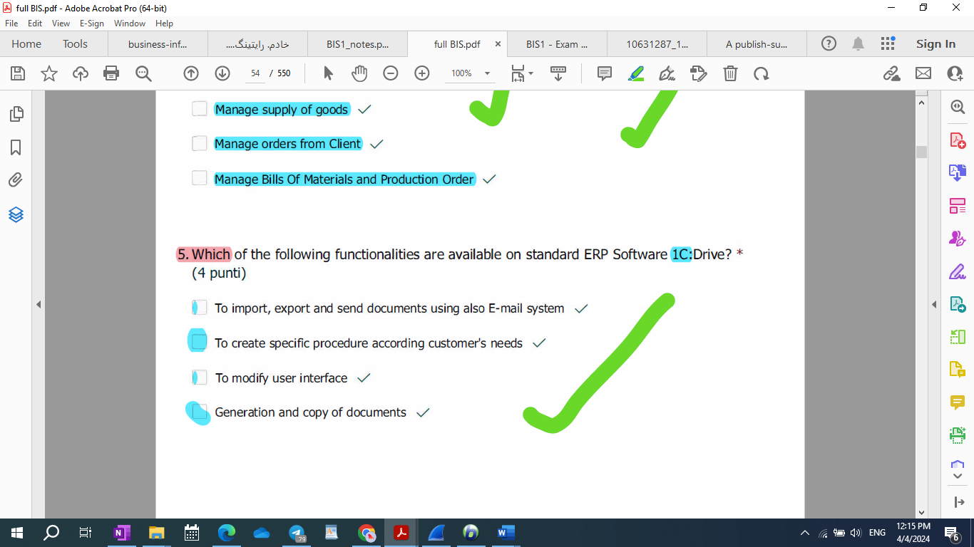

12-What is bounded rationality? *

1. Bouded rationality represents the limited information processing capacity (IPC) of

individuals.

1. Bounded rationality is the reason why individuals cooperate.
2. According to Galbraith, bounded rationality is the rational limit of both human and

artificial intelligence.

1. Bounded rationality is a coordination mechanism.

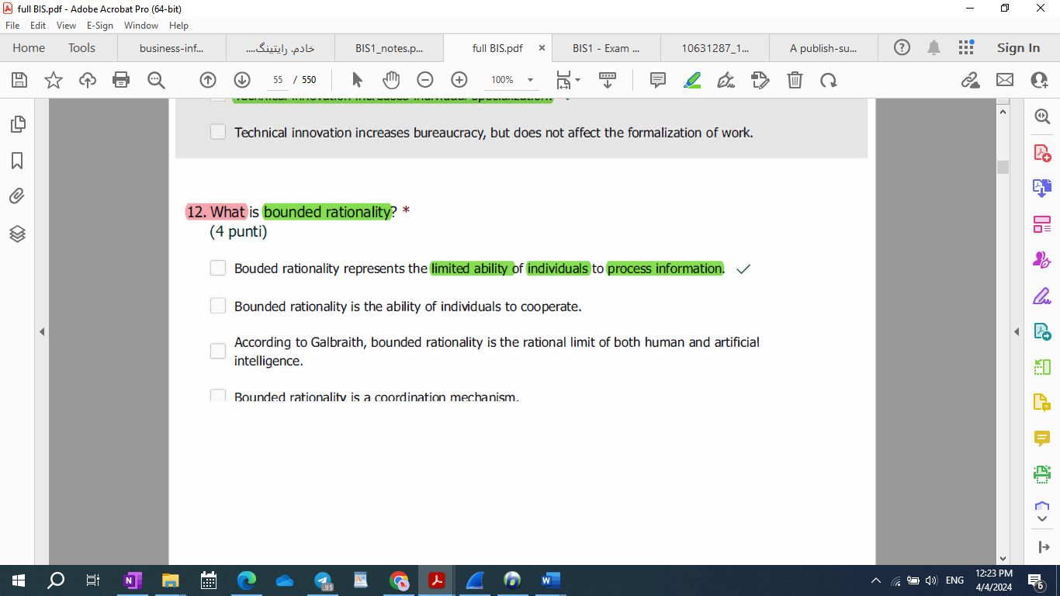

What is a CSF? *

* 1. CSF stands for critical success factor
  2. A critical success factor is a business decision variable critical for the success of the whole company, i.e. a must for success (necessary condition)
  3. A CSF is a key performance indicator
  4. A CSF is a set of key performance indicators

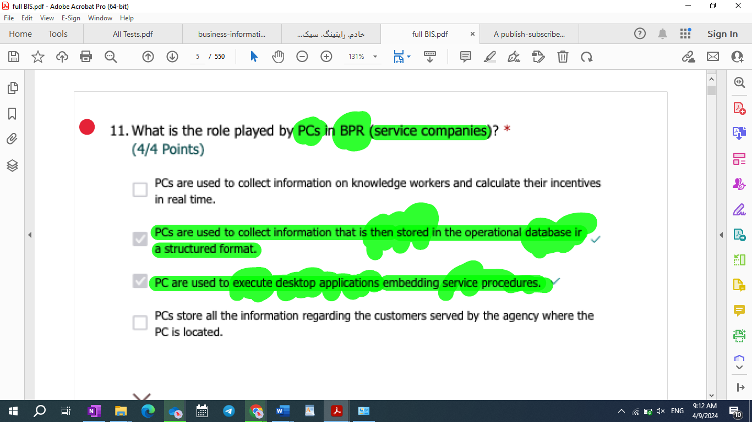

* 13-R-M: What is the role played by PCs in BPR (business process reengineering)?

1. PCs can be integrated with CIM and MRP.
2. PCs represent a production technology
3. PCs provide enough flexibility to support knowledge work and related decision-making activities.
4. PCs automate knowledge work

What is the role played by IT in the service industry? *

(0/4 Points)

1. Distribution technology.
2. Management technology.
3. Production technology.
4. Support to optimization of production resources.

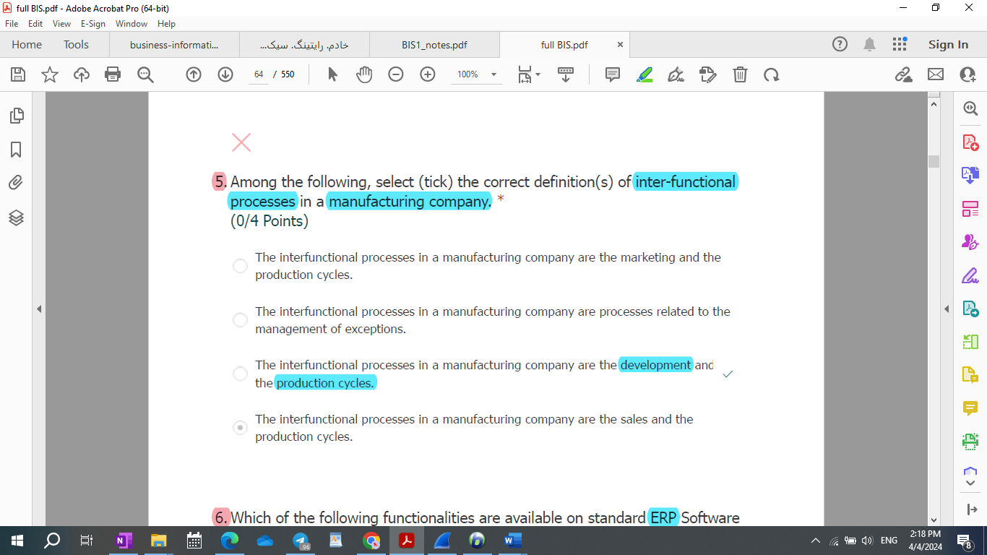

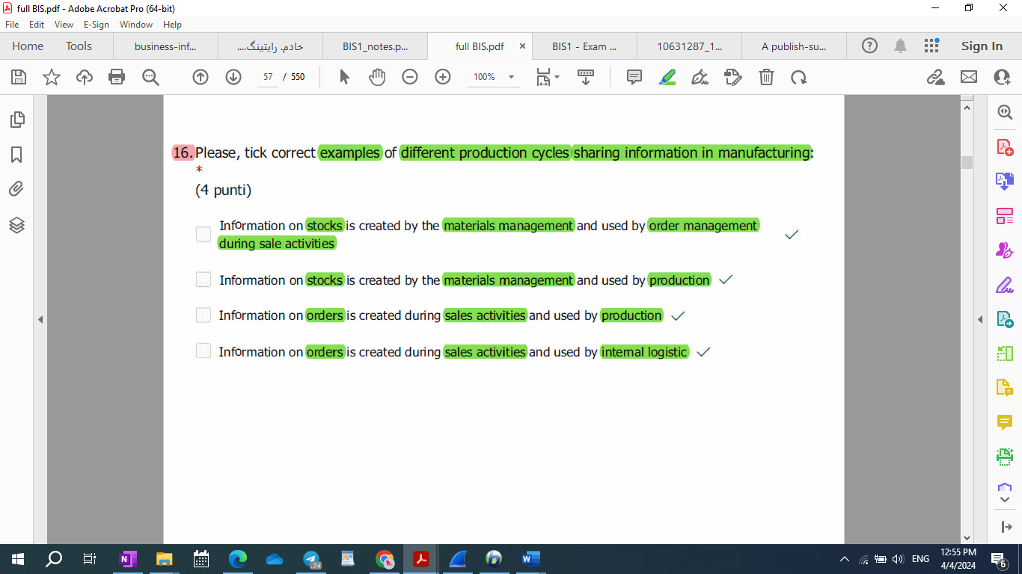

* Please, tick correct examples of different production cycles sharing information in manufacturing:

1. Information on stocks is created by the materials management and used by order management during sale activities
2. Information on stocks is created by the materials management and used by production
3. Information on orders is created during sales activities and used by **R&D**
4. Information on orders is created during sales activities and used by internal logistic

* Please, tick correct examples of different production cycles sharing information in manufacturing:

1. Information on stocks is created by the materials management and used by order management during sale activities.
2. Information on stocks is created by the materials management and used by production.
3. Information on orders is created during sales activities and used by production.
4. Information on orders is created during sales activities and used by internal logistic.

* Different production cycles share information, e.g.:
  1. Information **on stocks** is **created by** the **materials management** and **used by** **order management** during sale activities.
  2. Information **on stocks** is **created by** the **materials management** and **used by** **production.**
  3. Information **on orders** is **created during** **sales activities** and **used by** **production.**
  4. Information **on orders** is **created during** **sales activities** and **used by** **internal logistic.**

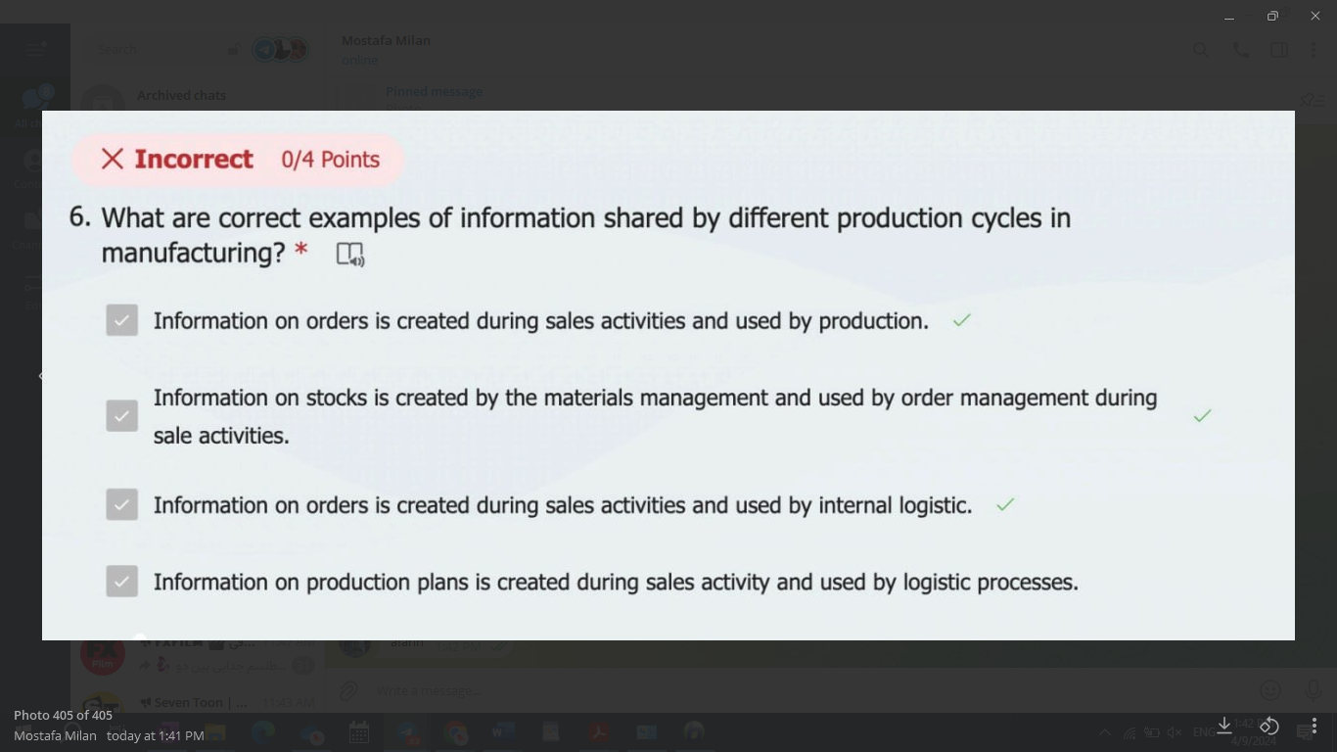

|  |  |  |  |
| --- | --- | --- | --- |
| Information on stocks | Created by material management | Use by order management + production |  |
| Information on orders | Created during the sales activities | Used by production + internal logistic | Used by R&D |
| On production plans | Created during sales activities |  | Used by logistic processes |

|  |  |  |
| --- | --- | --- |
| Information stack created by material management used by | Order management during sales activities – used by | production |
| internal logistics |
| production |  |

R-M: Repeated What is (are) the purpose(s) of an ETL procedure?

1. Allow to register documents of different business areas in a single database
2. **Extract** data from a source perform data modeling and upload data in a target structure
3. Allow analytics on different data sources simultaneously
4. **Extract** data from a system to import them in a different one

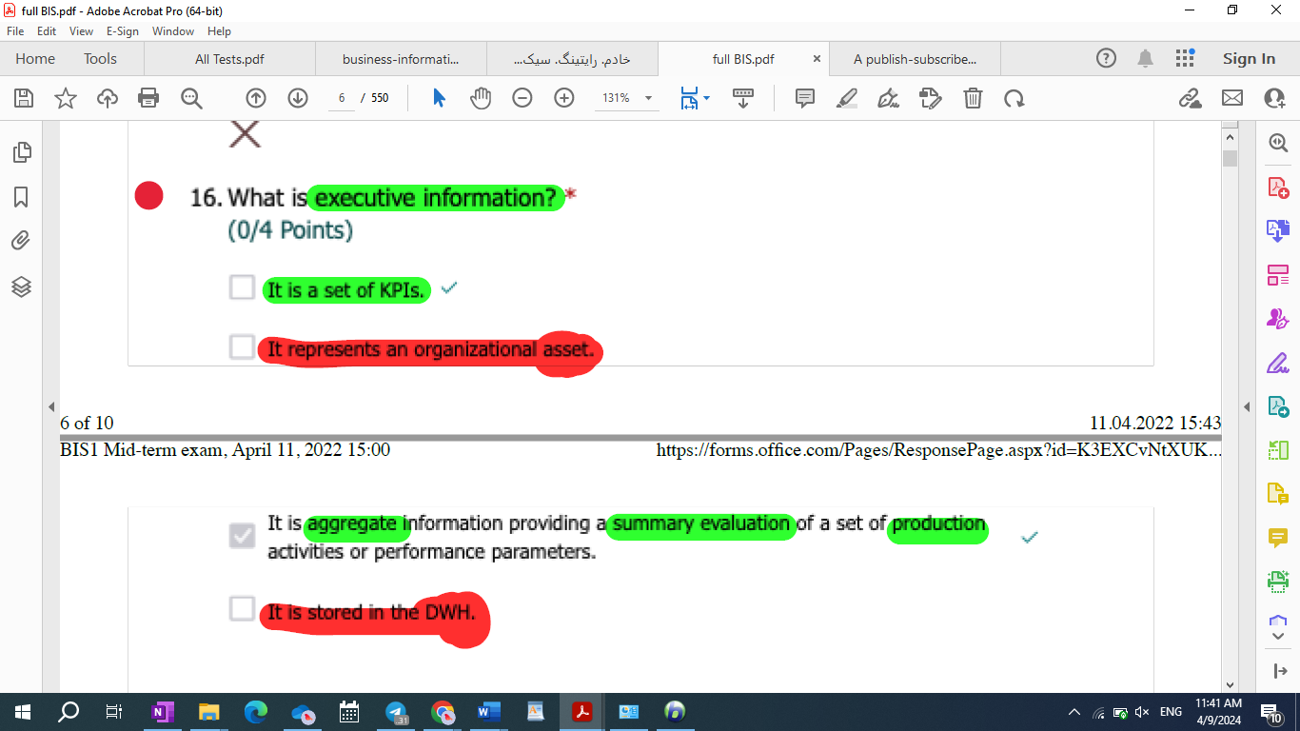

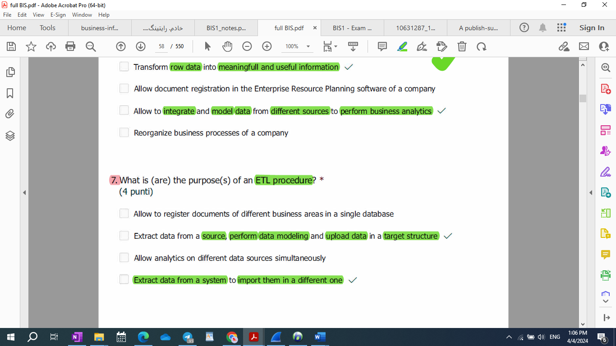

What are characteristic(s) of market systems? *

1. They reduce behavioural uncertainty by leveraging opportunism.
2. In market systems **production costs are low**, as individuals tend to be **very efficient**.
3. Market coordination involves the execution of transactions.
4. Markets replace hierarchies, since markets have lower production costs.

What are characteristic(s) of market systems? *

1. They reduce behavioural uncertainty by leveraging opportunism.
2. In market systems production costs are low, as individual tend to be very efficient.
3. Market coordination involves the excution of transactions.
4. Markets replace hierarchies, since markets have lower production costs.

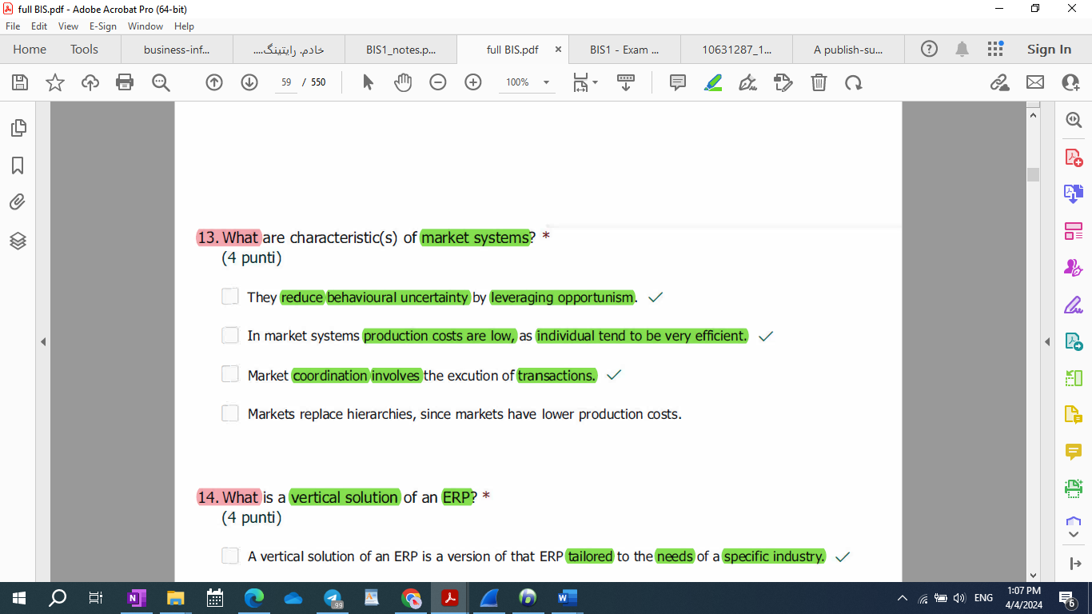

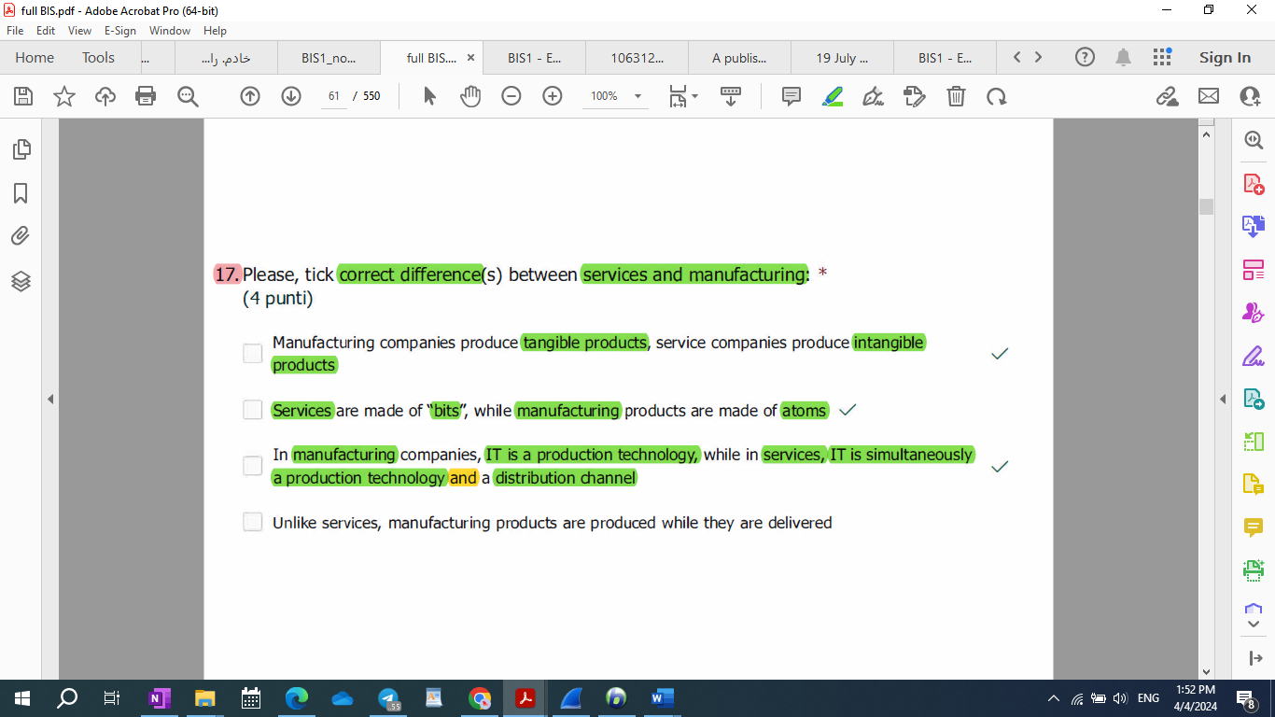

* Repeated Please, tick correct difference(s) between services and manufacturing: *

1. Manufacturing companies produce tangible products, service companies produce intangible products
2. Services are made of “bits”, while manufacturing products are made of atoms
3. In manufacturing companies, IT is a production technology, while in services, IT is simultaneously a production technology and a distribution channel
4. Unlike services, manufacturing products are produced while they are delivered

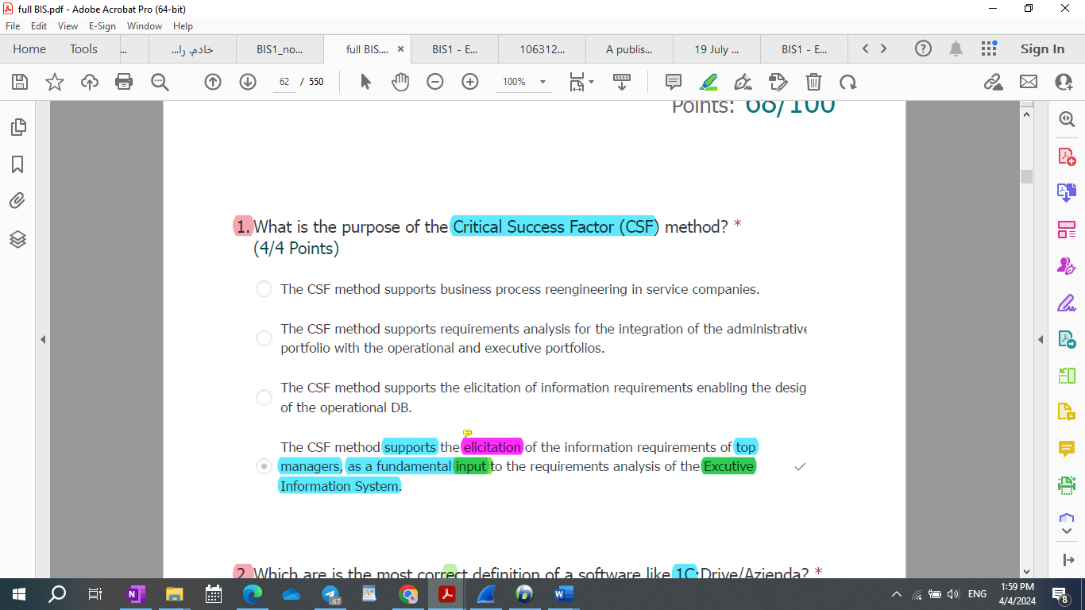

Repeated: What is the purpose of the Critical Success Factor (CSF) method? *

1. The CSF method supports the elicitation of information requirements enabling the design of the operational DB.
2. The CSF method supports the elicitation of the information requirements of top managers, as a fundamental input to the requirements analysis of the Excutive Information System.
3. The CSF method supports requirements analysis for the integration of the administrative portfolio with the operational and executive portfolios.
4. The CSF method supports business process reengineering in service companies.

45 - What is the purpose of the Critical Success Factor (CSF) Method? S P

* 1. The CSF Method support the elicitation of the information requirements of top managers, as a fundamental input to the requirements analysis of the Executive Information System.
  2. The CSF Method support requirements analysis for the integration of the administrative portfolio with the operational and executive portfolio.
  3. The CSF Method support the elicitation of the information requirements enabling the design of the operational DB.
  4. The CSF Method support the process reengineering in service companies.

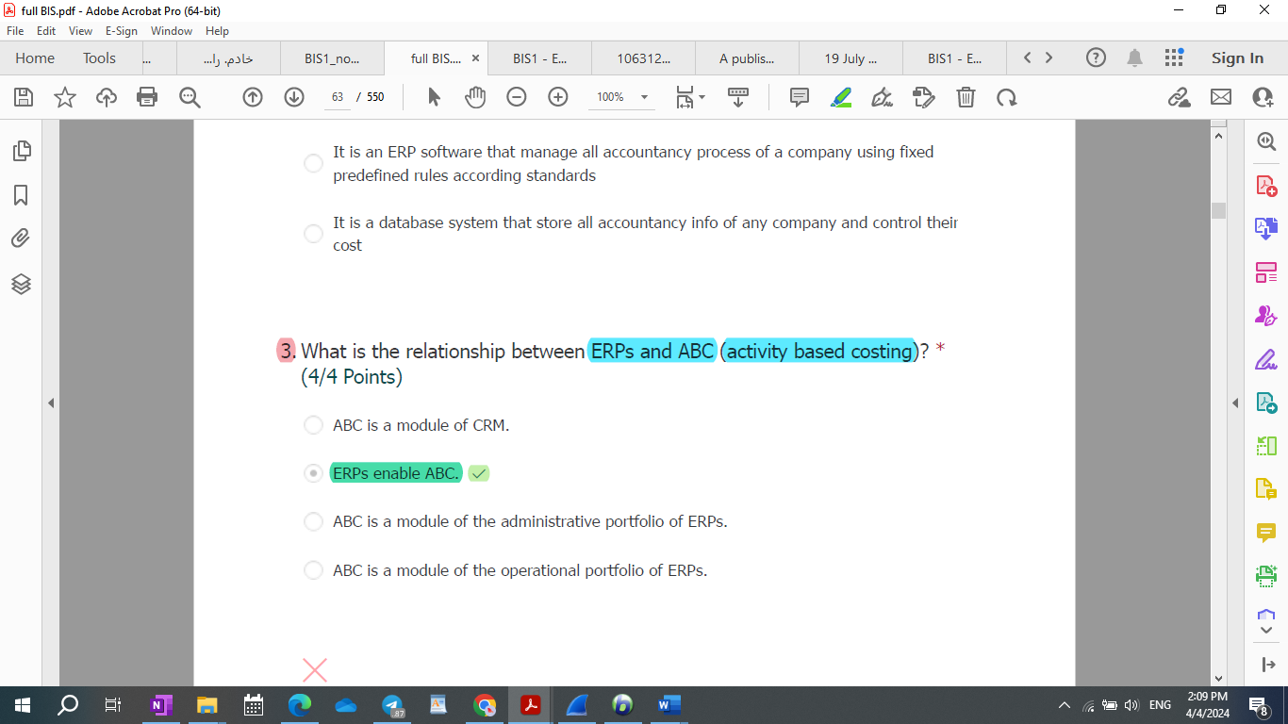

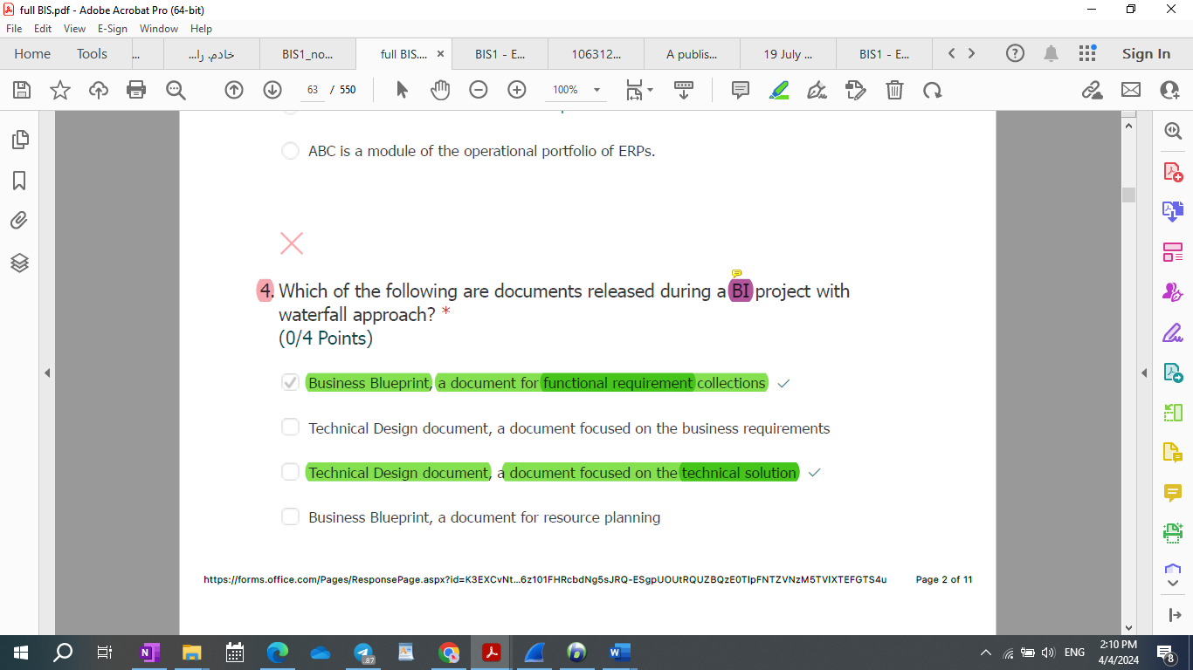

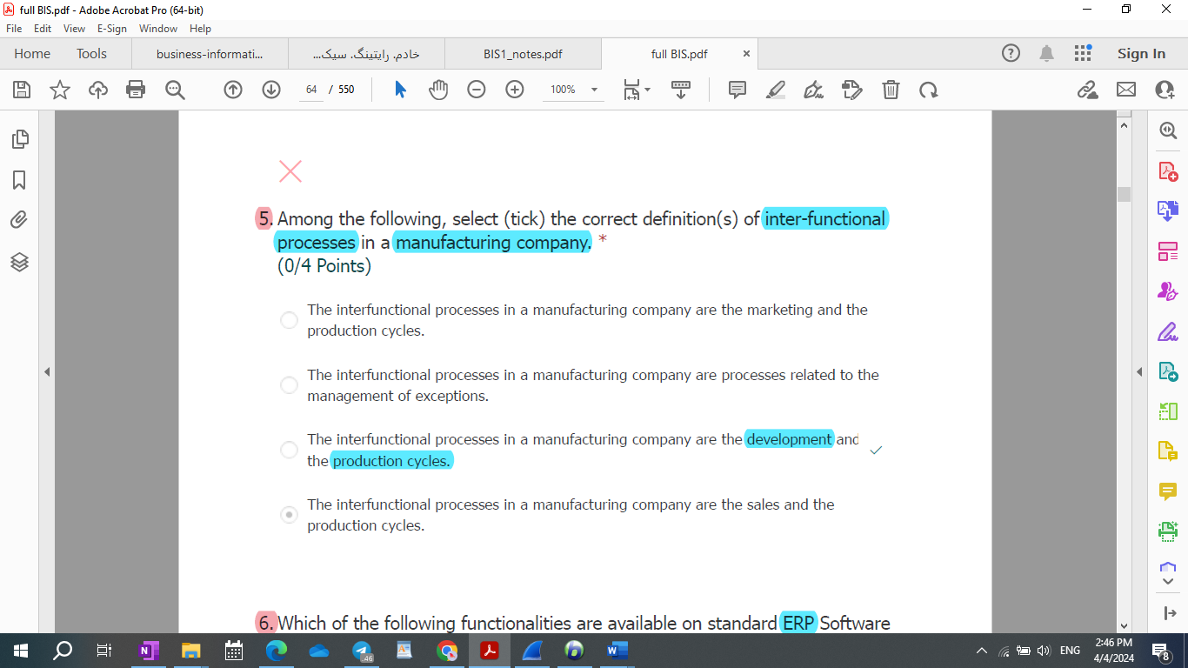

Among the following, select (tick) the correct definition(s) of inter-functional processes in a manufacturing company. *

(4/4 Points)

* 1. The interfunctional processes in a manufacturing company are the sales and the production cycles.
  2. The interfunctional processes in a manufacturing company are the development and the production cycles.
  3. The interfunctional processes in a manufacturing company are the marketing and the production cycles.
  4. The interfunctional processes in a manufacturing company are processes related to the management of exceptions.

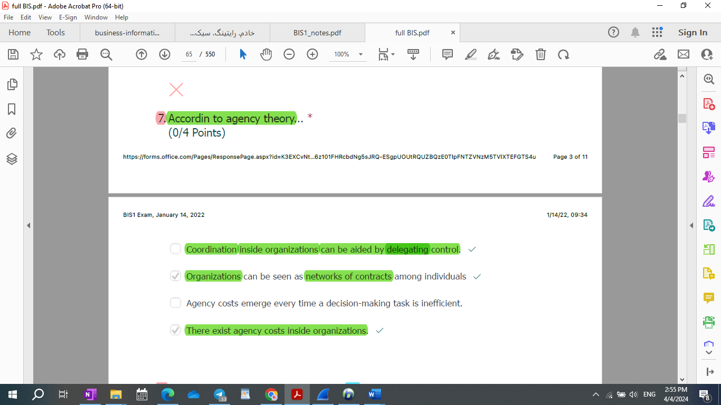

* 1. Organizations are seen as networks of contracts among individuals
  2. Agency costs emerge every time a decision-making task is inefficient.
  3. Coordination inside organizations can be based only on command and control.
  4. There exist transaction costs inside organizations.

According to agency theory… *

1. Coordination inside organizations can be aided by delegating control.
2. Organizations can be seen as networks of contracts among individuals
3. Agency costs emerge every time a decision-making task is inefficient.
4. There exist agency costs inside organizations.

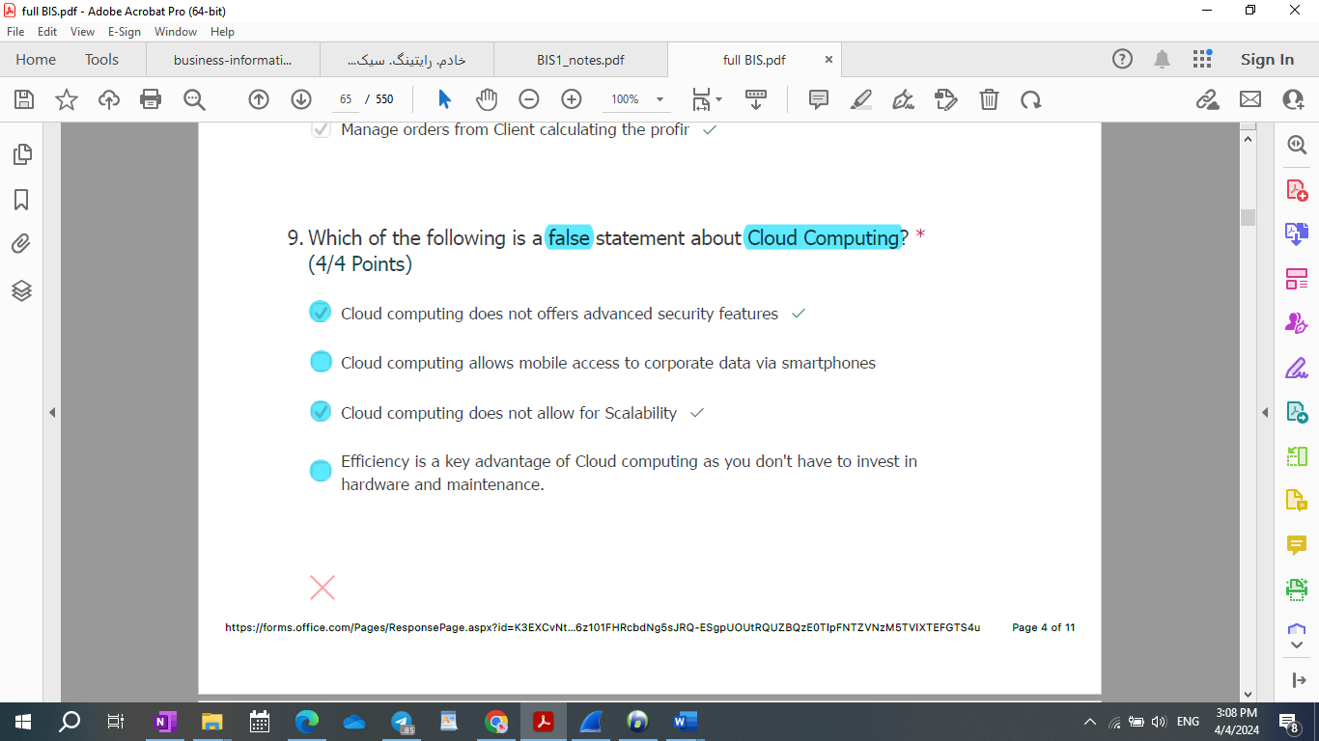

* Which of the following is a false statement about Cloud Computing?
  1. Cloud computing does not allow for Scalability.
  2. Cloud computing allows mobile access to corporate data via smartphones
  3. Cloud computing does not offers advanced security features
  4. Efficiency is a key advantage of Cloud computing as you don’t have to invest in hardware and maintenance.

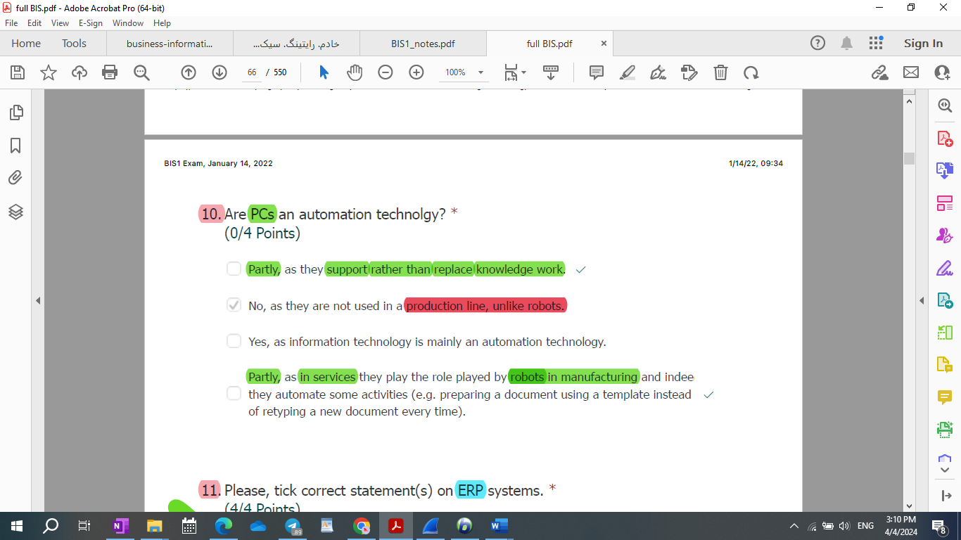

Are PCs an automation technolgy? *

1. Yes, as in services they play the role played by robots in manufacturing.
2. No, as they support rather than replace knowledge work.
3. No, as they are not used in a production line, unlike robots.
4. Yes, as information technology is mainly an automation technology.

* Are PCs an automation technolgy?
* [ ] No, as they are not used in a production line, unlike robots.
* [x] No, as they support rather than replace knowledge work.  
   No
* [ ] Yes
* [ ] Yes, in manufacturing
* [ ] Yes, in services
* [ ] Yes, as in services they play the role played by robots in manufacturing
* [ ] Yes, as information technology is mainly an automation technology

Are PCs an automation technolgy? *

1. Partly, as they support rather than replace knowledge work.
2. No, as they are not used in a production line, unlike robots.
3. Yes, as information technology is mainly an automation technology.
4. Partly, as in services they play the role played by robots in manufacturing and indee they automate some activities (e.g. preparing a document using a template instead of retyping a new document every time).

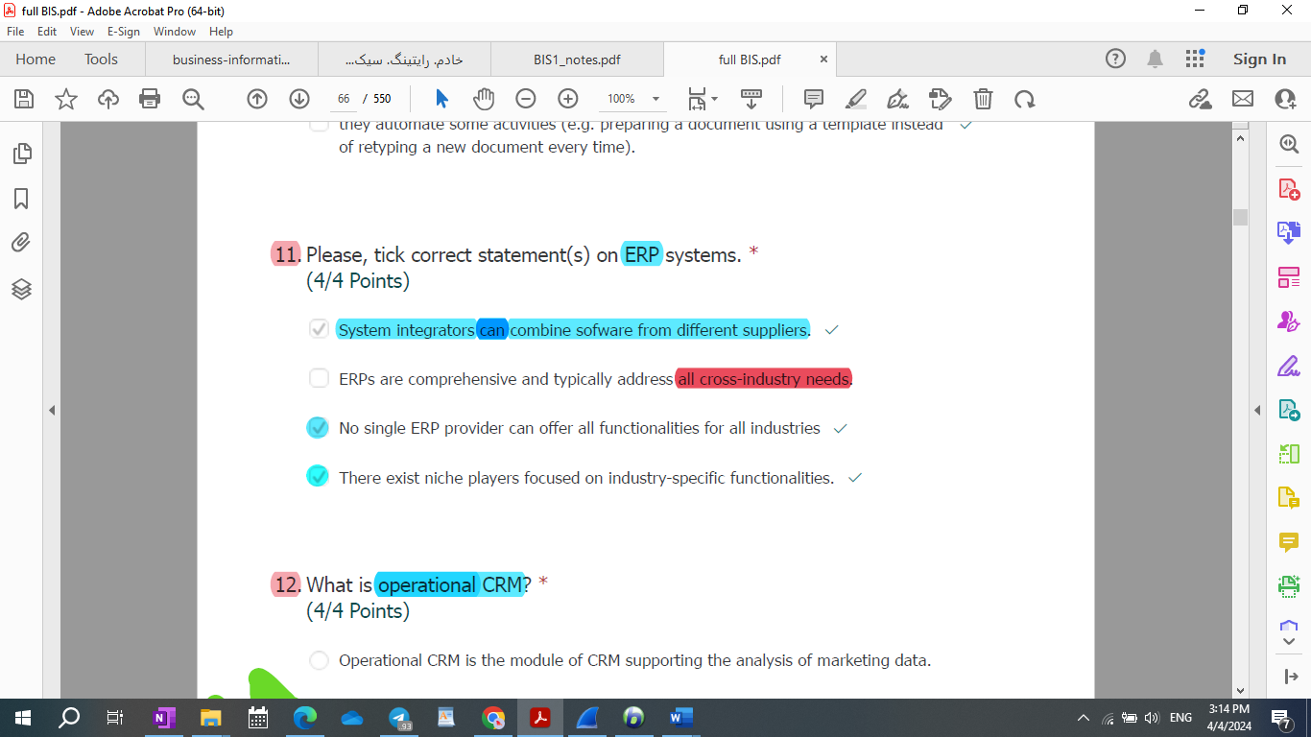

Please, tick correct statement(s) on ERP systems.

1. System integrators can combine software from different suppliers.
2. ERPs are comprehensive and typically address **all** cross-industry needs.
3. No single ERP provider can offer all functionalities for all industries
4. There exist niche players focused on industry-specific functionalities.

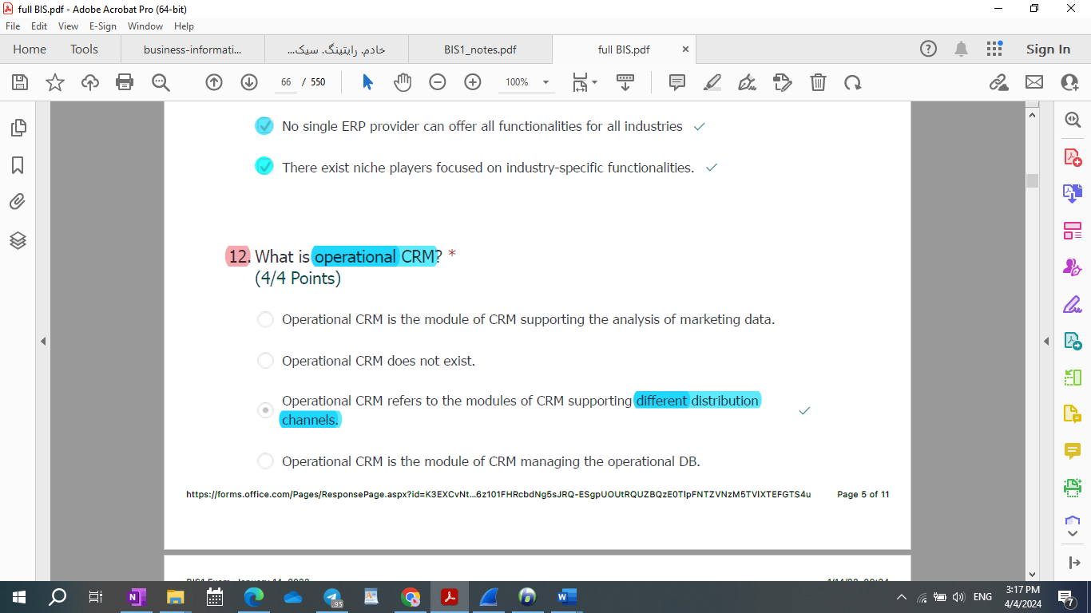

What is operational CRM? *

(4/4 Points)

Operational CRM is the module of CRM supporting the analysis of marketing data.

Operational CRM is the module of CRM managing the operational DB.

Operational CRM does not exist.

Operational CRM refers to the modules of CRM supporting different distribution channels.

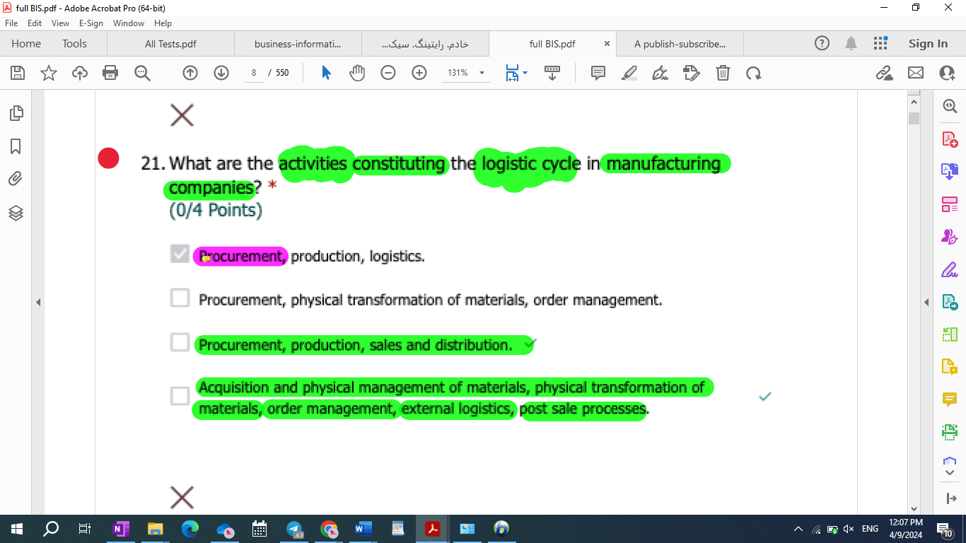

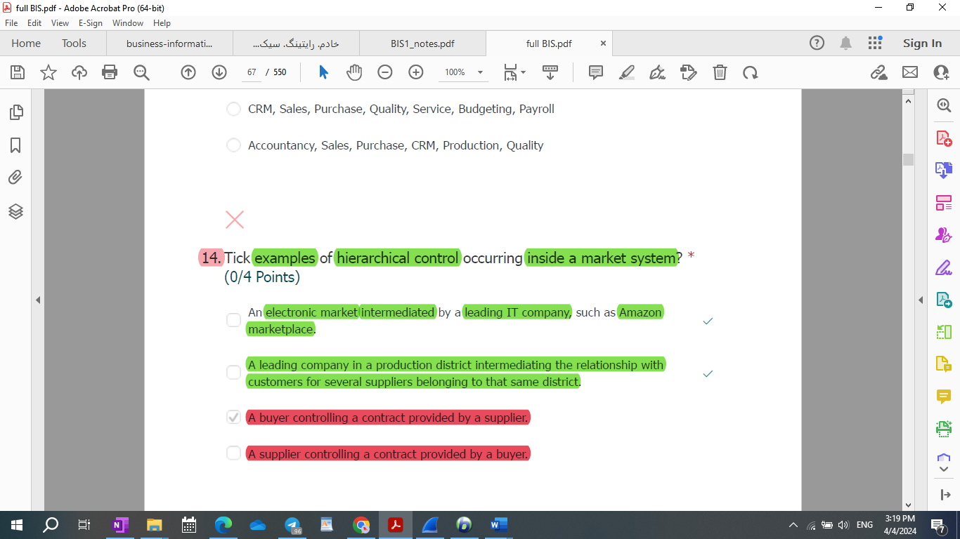

* 6-R-M: Please tick correct statement(s) on hierarchical control in market systems:

1. In non perfect markets, customers may have some level of hierarchical control on their **customers’ production processes**.
2. Market and hierarchies are separate coordination systems that can mix only inside organizations.
3. In non perfect markets, customers can control their suppliers to some extent.
4. Hierarchical control does not exist in perfect market systems.

* Can hierarchical control occur inside market system? * (4/4 Points)  
  1- In perfect market systems, yes.  
  2- In perfect market systems, no.   
  3- Yes, when customers can control their suppliers to some extent.  
  4- No.
* Tick examples of hierarchical control occurring inside a market system? (0/4 Points)

1. An electronic market intermediated by a leading IT company, such as Amazon marketplace.
2. A leading company in a production district intermediating the relationship with customers for several suppliers belonging to that same district.
3. A buyer controlling a contract provided by a supplier.
4. A supplier controlling a contract provided by a buyer.

According to agency theory  
  
1- Organizations are seen as networks of contracts among individuals  
2- Agency costs emerge every time a **decision-making** task is inefficient.  
3- Coordination inside organizations can be **based** only on command and control.  
4- There exist transaction costs inside organizations.

According to agency theory… *

1. Coordination inside organizations can be **aided** by delegating control.
2. Organizations can be seen as networks of contracts among individuals
3. Agency costs emerge every time a **decision-making** task is inefficient.
4. There exist agency costs inside organizations.

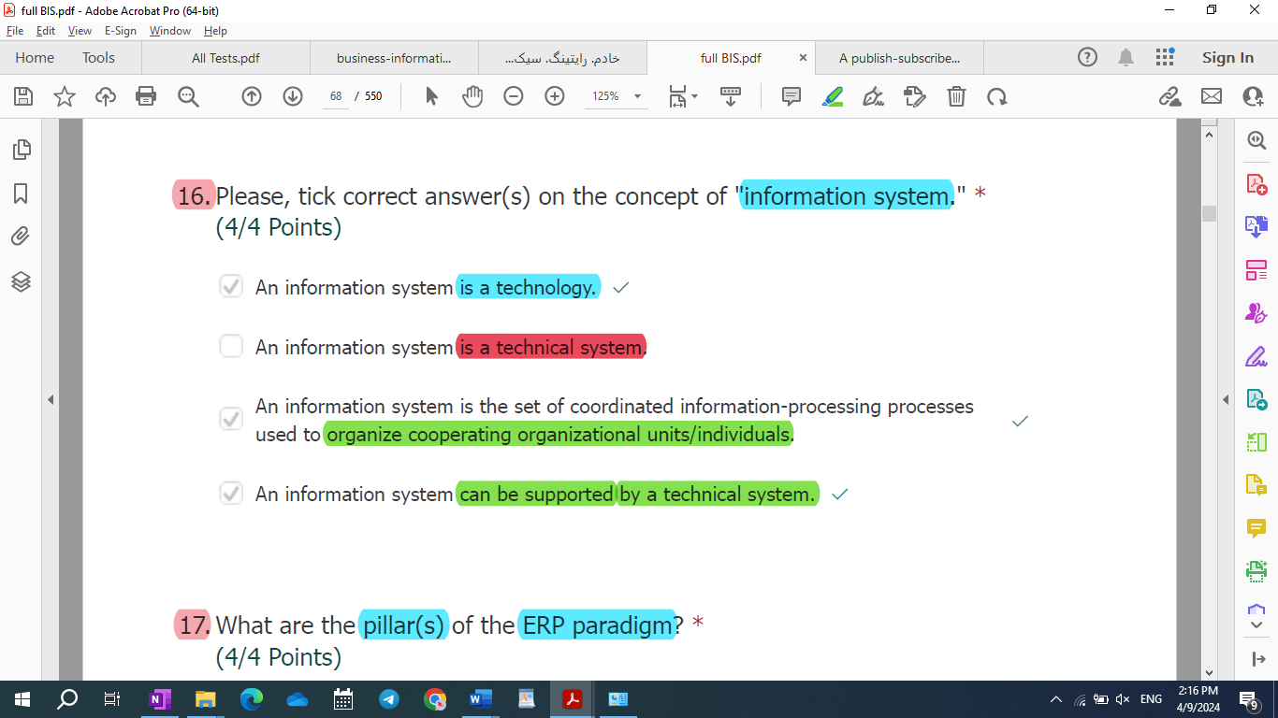

54) Please, tick the correct definition(s) of “delegation” according to agency

theory.

1. Delegation represents a continuous learning process that allows employees to be promoted to higher job positions in the hierarchy.

**2. Delegation represents an organizational must to make vertical information systems more efficient when environmental uncertainty is too high.**

3. Delegation represents a task with which a responsibility higher in the hierarchy enables another responsibility lower in the hierarchy to execute a set of production activities.

**4. Delegation represents a task with which a responsibility higher in the hierarchy enables another responsibility lower in the hierarchy to make decisions on a set of interrelated activities.**

Why is the market system more suitable than the hierarchical system to

cope with behavioral uncertainty?

**1. Because in a pure market system, individuals produce for themselves and, therefore, their objectives coincide with their organizational objectives as entrepreneurs.**

2. Because in a market system, individuals are not subject to hierarchical control.

3. Because in a market system, organizations can resort to "buy" solutions in make or buy decision processes.

4. **Because the coincidence between individual and organizational objectives in a pure market system makes individuals more willing towork and achieve their goals as entrepreneurs.**

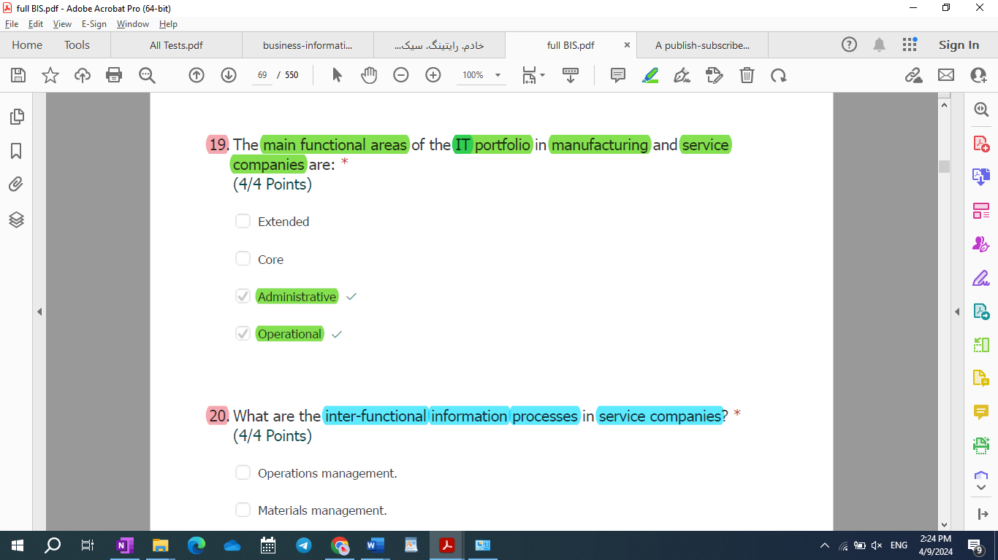

Executive portfolio not extended portfolio

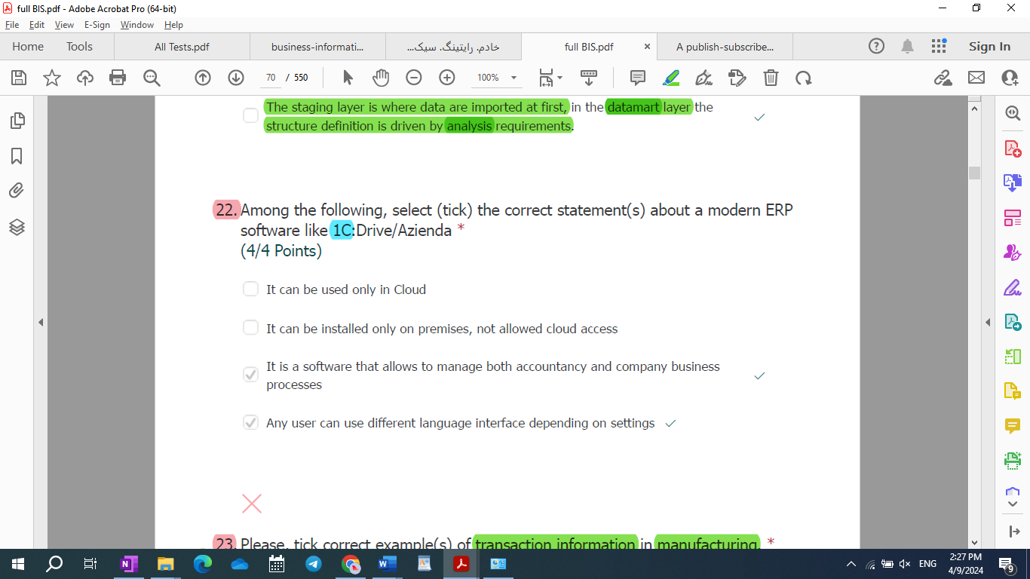

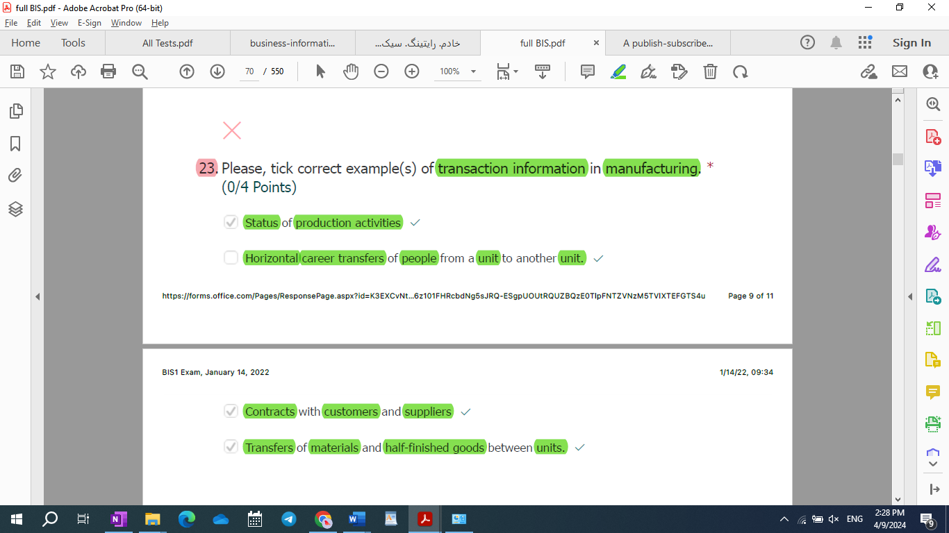

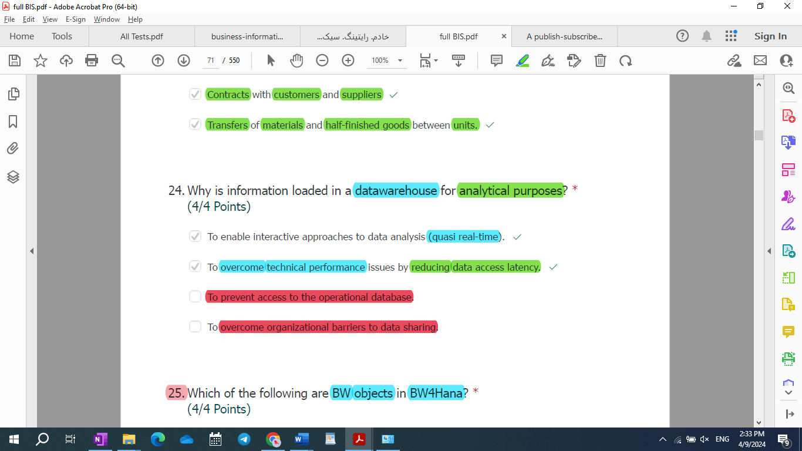

What are typical dimension(s) of an indicator in an executive information system? *

(4/4 Points)

20.

Stocks

Managers

Customers

Processes

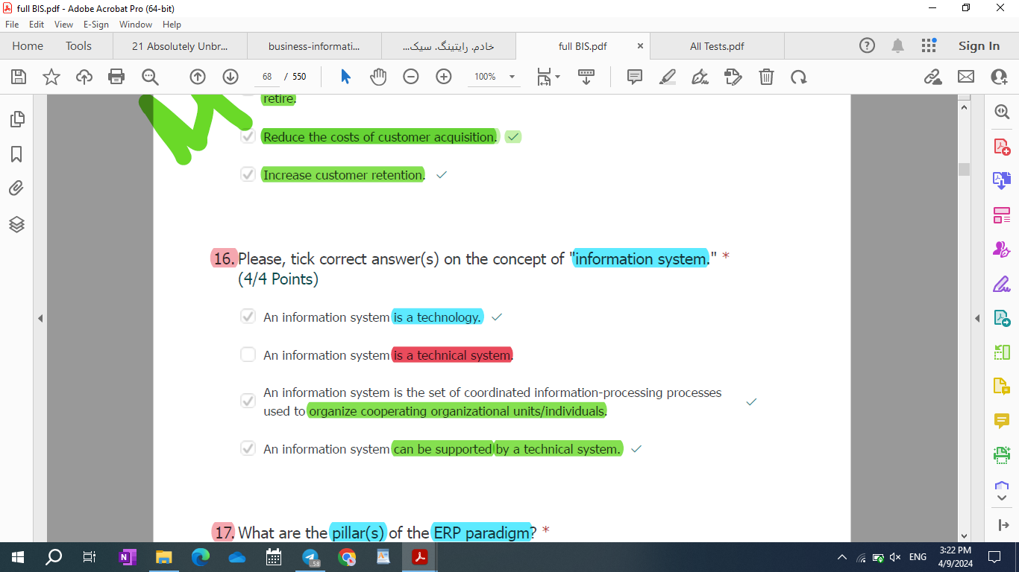

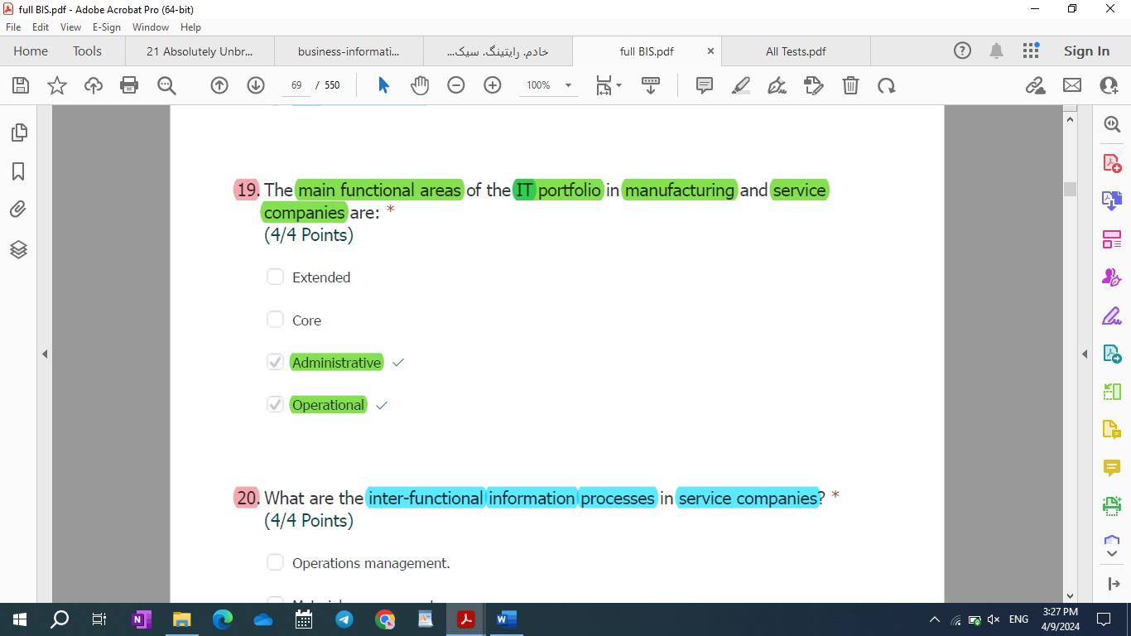

1. Key performance indicators
2. to pay back a debt by making small regular payments over a period of time
3. Key performance indicators
4. **You should write it at the end of multiple choice question when you are asking the question from chat GPT.**